CFIHOS – Specification Document

|  |  |  |
| --- | --- | --- |
| Version | Date | Comments/History |
| 1.4 | April 2020 | IOGP republication of CFIHOS document first published in October 2019. |
| 1.4.1 | December 2020 | New sections added:  2. ‘Purpose and Objectives’ (previously part of section 1. Scope)  8. ‘Models’ |
| 1.5 | October 2021 | Broadened PDF requirements to include scans or renderings in section 7.4.5. Updated Annex A.2 Figure 3 to include process, streams and classes and section 6.2 to reference all figures in Annex A.2. |
| 1.5.1 | 2022-11 | Minor text changes for bug fixes throughout the text of the document. Added ISO 8601 reference |

Acknowledgements

In 2012, Shell approached Netherlands-based process industry organization USPI to explore turning their corporate information standard into an industry-wide standard. The result was the CFIHOS (Capital Facilities Information Handover Specification) project.

Its aim is to offer practical, standardized specifications for information handover that work across the supply chain – operators, contractors and suppliers. The most recent CFIHOS industry standard (Version 1.4) was published in October 2019 by USPI with support from the Engineering Advancement Association of Japan (ENAA). This document, describing the scope and procedures of CFIHOS, is part of this standard.

Following a member vote in 2019, the future governance, development, and maintenance of the CFIHOS project and standard moved from USPI to IOGP in January 2020, becoming Joint Industry Project (JIP)36.

**Disclaimer**

Whilst every effort has been made to ensure the accuracy of the information  
contained in this publication, neither IOGP nor any of its Members past present or  
future warrants its accuracy or will, regardless of its or their negligence, assume  
liability for any foreseeable or unforeseeable use made thereof, which liability is  
hereby excluded. Consequently, such use is at the recipient’s own risk on the basis  
that any use by the recipient constitutes agreement to the terms of this disclaimer.  
The recipient is obliged to inform any subsequent recipient of such terms.

This publication is made available for information purposes and solely for the private  
use of the user. IOGP will not directly or indirectly endorse, approve or accredit the  
content of any course, event or otherwise where this publication will be reproduced.

**Copyright notice**

The contents of these pages are © International Association of Oil & Gas Producers.  
Permission is given to reproduce this report in whole or in part provided (i)   
that the copyright of IOGP and (ii) the sources are acknowledged. All other rights are  
reserved. Any other use requires the prior written permission of IOGP.

These Terms and Conditions shall be governed by and construed in accordance  
with the laws of England and Wales. Disputes arising here from shall be exclusively  
subject to the jurisdiction of the courts of England and Wales.

Contents

Page

Contents 3

Foreword 5

Introduction 6

1. Scope 6

2. Purpose and Objectives 6

3. Normative References 7

4. Terms, Definitions, Acronyms and Abbreviations 7

5. Applicable Standards and Documents 8

5.1. International Standards 8

5.2. CFIHOS Reference Data Library (RDL) 9

6. Data 9

6.1. General 10

6.1.1. Plant Breakdown Structure 10

6.1.2. Process, Streams and Cases 10

6.1.3. Tag and Equipment Class Properties 10

6.2. Data Specification 10

7. Documents 11

7.1. General 11

7.2. Document Specification 12

7.2.1. Document Numbering 12

7.2.2. Discipline 12

7.2.3. Document Type Classification 12

7.2.4. Discipline Document Type Classification 12

7.3. Document Properties (Metadata) 13

7.4. Document and File Structures 13

7.4.1. Document Books (or binders) 13

7.4.2. File Requirements 13

7.4.3. Additional Files 14

7.4.4. Files to be delivered 15

7.4.5. Image Quality 15

7.4.6. Hyperlinks 15

7.4.7. Different Languages 15

7.4.8. Character Set 16

7.4.9. Document Size 16

7.5. Document References 16

7.6. Physical Record Requirements 16

8. Models 17

8.1. General 17

8.2. 3D Model 18

8.2.1. Photogrammetry and LIDAR Survey Specification 19

8.2.2. Coordinate Alignment Specification 19

9. Bibliography 19

Annex A - Information Specification 20

A.1 General 20

A.2 Data Model 20

A.2.1 How to read the data model 20

A.2.2 High-level views of the CFIHOS data model 21

A.2.3 Complete set of views of the CFIHOS data model 24

A.3 Data Dictionary 25

A.3.1 How to understand the data dictionary 25

A.3.2 CFIHOS Data Dictionary excerpt 26

A.3.3 Access to the CFIHOS Data Dictionary 26

Tables

Table 1 - Handover Models 16

Table 2 - Data Dictionary Descriptions 24

Figures

Figure 1 - High-level overview of the complete model 21

Figure 2 - Overview of the Plant Breakdown Structure 21

Figure 3 - Overview of the Classifications and Properties 22

Figure 4 - Overview of the document management metadata 22

Foreword

The Capital Facilities Information Handover Specification (CFIHOS) is an industry standard developed to improve how technical information is exchanged between Principals, Contractors and Suppliers/Manufacturers for the process and energy sectors. Starting with a common engineering dictionary and supporting specifications, the CFIHOS goal is to become a common language for the exchange of technical information in these sectors.

CFIHOS is being developed collaboratively by Principal (Owner/Operator) companies, EPC Contractors, software providers and equipment vendors/suppliers/manufacturers as a practical standard to ensure the systematic and reliable exchange of information among all companies involved in the data supply chain, thereby reducing cycle times and costs.

The initial focus is on the information, as computer models, structured data and traditional document formats, are handed over when a project moves from its development to operations phase. Ultimately, the aim is for CFIHOS to become the de-facto standard for information exchange throughout the physical asset lifecycle, from vendor information through to decommissioning.

Introduction

This document provides the requirements for engineering information handover specification for capital facilities between Principals, Contractors and Suppliers/Manufacturers. It specifies the engineering information Principals require for future operation and maintenance of their facilities.

CFIHOS Implementation Guide for Principal [C-GD-001] and CFIHOS Implementation Guide for Contractor [C-GD-002] provide detailed guidance on how to use this specification.

# Scope

This specification covers:

* Handover of information for production facilities
* Handover of information along the process industry plant engineering supply chain that consists of Principals, Contractors, and Suppliers/Manufacturers

Where:

* + The Principal is the end client company that owns the production facility and is responsible for operation and maintenance
  + The Contractor is responsible for design, detailed engineering, procurement, construction and commissioning of a facility
  + The Maintenance Contractor maintains and/or operates the facility
  + The Supplier/Manufacturer delivers the equipment used to construct a facility and is responsible for the design, manufacturing and assembly of a particular piece of equipment.
* That part of engineering information created by a Contractor and Supplier/Manufacturer required by the Principal to operate and maintain a facility and to support future design changes.

Out of scope for this specification:

* Engineering information created by a Contractor and Supplier/Manufacturer that is not required by a Principal to operate and maintain a facility or to support any future design changes
* Processes that govern how a Contractor or Supplier/Manufacturer creates and/or quality assures the engineering information
* Systems used to develop the information nor the systems in which the information will be quality assured and stored at handover.

# Purpose and Objectives

Create a standard specification for Principals, Contractors and Suppliers/Manufacturers for the handover of engineering information in a facilities project, such that:

* This specification is an integral part of the full set of specifications which specifies the:
  + Physical plant
  + Information required.
* The information satisfies:
  + Information requirements from statutory authorities
  + Approval and acceptance of delivery by the involved stakeholders
  + Design for future changes to the plant
  + Operation and Maintenance during the lifetime of the plant.
* The specification can be applied across the supply chain.

# Normative References

|  |  |
| --- | --- |
| C-TP-001 | CFIHOS Scope and Procedure |
| C-GD-001 | CFIHOS Implementation Guide for Principal |
| C-GD-002 | CFIHOS Implementation Guide for Contractor |
| C-ST-001 | CFIHOS Reference Data Library (RDL) |
| C-DM-001 | CFIHOS Data Model |
| C-DM-002 | CFIHOS Data Dictionary |
| C-GD-003 | CFIHOS Knowledge Guide (Note: this document is not yet issued) |

# Terms, Definitions, Acronyms and Abbreviations

**Additional Files:** A logical collection of physical computer files that are associated to **one** document revision identification.

**Application**: A computer program designed to help people perform an activity.

**Approved For Construction**: Formal milestone indicating the start of construction/erection activities. Information assigned this status may be used to support construction activities.

**As-Built:** Describing documentation, data and models associated with the facility, system or component that represents the actual physical “as is” situation.

**As-Design:** Documentation, data and models associated with the facility, system or component that represents the initial design and subsequently incorporates all approved design changes.

**Contract Information Management Scope of Work:** Document in which the Principal specifies the terms and conditions for information delivery by the Contractor. Where it is applicable and feasible, quality benchmarks and criteria to fulfil them may be included.

**Contract RDL**: Document in which the Principal specifies the requirements of the RDL specific for the scope of contract based on the CFIHOS RDL and may include deviations from or additions to the CFIHOS RDL.

**Contractor:** The party that carries out all or part of the design, engineering, procurement, construction, commissioning or management of a project or operation of a facility.

**Controlled Document:** Digital or hard-copy entity which is required by a company, a standards organization, or a regulatory agency to be managed within a tightly controlled process that maintains the integrity of its content through revision control.

**Discipline Document Type**: An association between Disciplines and Document Class names. In the CFIHOS context, this is a unique identifier for types of documents and has been developed for situations where a document class is common to more than one discipline. For example, a process engineering flow scheme should only be produced by the process discipline, whereas a data sheet could be produced by many disciplines depending on the equipment where each discipline is responsible for part of the content.

**Export Control Classification Number (ECCN):** An alphanumeric code that identifies the level of export control for articles, technology and software (collectively, "Items") that are exported from member states of the Wassenaar Arrangement on Export Controls for Conventional Arms and Dual-Use Goods and Technologies, including the United States. The ECCN classification that applies to any specific item is determined by referring to a table such as that issued for the United States by the Bureau of Industry and Security and for Europe by Regulation 428/2009.

**Handover of Information:** The formal process between Principal and Contractor for transfer of ownership and responsibility for the change management of information aligned with the official acceptance of a physical facility.

**Handover Plant Breakdown Structure**: The plant breakdown structure that structures the handover deliverables in relation to the physical assets.

**Maintenance Contractor:** Party that maintains the plant on behalf of the Principal.

**Original Equipment Manufacturer** (OEM) is the company that originally manufactured the equipment item and from which the equipment supplier purchased the equipment ultimately for the Principal’s use.

**Principal:** Party that initiates the project and ultimately pays for it. This includes any agent or consultant authorised to act for, and on behalf of, the Principal.

**Reference Data Library (RDL):**  a standard and unified naming convention for equipment classification, its properties, disciplines and documents. It is a set of information requirement specifications for documents and tagged items.

**Supplier/Manufacturer:** Party that manufactures or supplies equipment and services to perform the duties specified by the Contractor. The Supplier/Manufacturer may be the Contractor where the client is the end consumer of the equipment/service.

**Master Tag Register (MTR):** List of tagged items the Principal would like to trace e.g. have technical data and documentation available, during the lifetime of an industrial plant. Note that:

* **shall** is used to indicate that a provision is mandatory
* **should** is used to indicate that a provision is not mandatory, but recommended as good practice.

**Aliases**

The words “facility” and “plant” are used interchangeably throughout this document.

# Applicable Standards and Documents

This section describes the applicable standards and practices relevant to this document in specifying what information is handed over to the Principal.

## International Standards

International standards relevant to this area of work include ISO 10303, ISO 14224, ISO 15926, and ISO 8601-1:

###### ISO 10303 is titled “Industrial Automation Systems and Integration - Product Data Representation and Exchange”, also known as STEP or the “Standard for the Exchange of Product model data”. It is a standard for the computer-deciphered representation and exchange of industrial product data. The objective is to provide a mechanism capable of describing product data throughout the life cycle of a product, independent from a particular system.

###### ISO 14224 is titled “Petroleum, petrochemical and natural gas industries -- Collection and exchange of reliability and maintenance data for equipment”. It provides a comprehensive basis for the collection of Reliability and Maintenance (RM) data in a standard format for equipment in all facilities and operations within the petroleum, natural gas and petrochemical industries during the operational life cycle of equipment.

###### ISO 15926 is titled: "Industrial automation systems and integration—Integration of life-cycle data for process plants including oil and gas production facilities". It specifies a conceptual data model for computer representation of technical information about process plants.

###### ISO 8601-1 2019 is titled: “Date and time — Representations for information interchange — Part 1: Basic rules “. It specifies a standard date format of YYYY-MM-DD.

## CFIHOS Reference Data Library (RDL)

The CFIHOS RDL [C-ST-001] provides a standard and unified naming convention for equipment classification, its properties, disciplines and documents. It is a set of information requirement specifications for documents and tagged items. The CFIHOS RDL contains the following:

###### List of classes for Tag and Equipment (what the equipment does and what it is)

###### List of properties (attributes, measures, characteristics etc.)

###### Lists of requirements by class (data and applicable document references)

###### List of disciplines

###### List of document types

###### Relationships between data entities

###### CFIHOS Unique ID codes.

Contractor shall deliver plant’s data and applicable document references in conformance with the Contract RDL based on the CFIHOS RDL [C-SP-001] and other Principal specific documents including, but not limited to, engineering tagging specification and document numbering specification.

By application of the CFIHOS RDL, Contractor is able to determine Principal’s information requirements, for example:

###### If a Tag is classified as a temperature transmitter, the CFIHOS RDL defines which entity attribute and class-specific properties for that temperature transmitter need to be delivered by the Contractor. Except for the entity attributes common to all classes, the property requirements would be different if a different classification is used

###### If a Document is classified as a Piping and Instrumentation Diagram, the CFIHOS RDL identifies the final status of the document to be handed over (e.g., As-Built), when a native file format is required (at handover, during project or not required) and a document’s representation type (e.g., structured data).

# Data

## General

### Plant Breakdown Structure

The Plant Breakdown Structure (PBS) defines the hierarchy of engineering data Objects and the relationships between them. (Annex A.2.2. Figure 2) defines the PBS recognised by the Principal for data handover.

### Process, Streams and Cases

At the earlier phase of plant lifecycle, that is preceding the “functional design of the plant and the specification of the assets (asset requirements)” phase, process activities (e.g. pumping, heating, distilling) and streams (e.g. flow of material, flow of heat/energy) data are generated to represent the functional requirements describing what conditions are necessary to convert (chemical) substances step-by-step into final products.

Processes and streams define the requirements for tags (e.g. ‘we need a tag to perform pumping’), tags define the specification for equipment (e.g. ‘we have to order a centrifugal pump with the following features to implement/fulfill this tag’). The scope of the information required for handover is not limited to the specifications for equipment, but also the requirements for tags.

Streams and Process Activities also have cases which enables the Principal to follow the thoughts of the Contractor Process Engineer who uses cases to view the various what-if scenarios of the process streams.

The relationship between Processes, Streams and Cases is presented in Annex A.2.2. Figure 3.

### Tag and Equipment Class Properties

A facility’s information is concerned with the functional definition of the facility (its operating parameters), and how the facility then fulfils the functional requirements i.e. the physical definition of the facility.

The Classification of the tag, equipment or model part engineering data object is used to define functional and physical data properties requirements

**Tag (functional) data properties** are the technical design requirements for a tagged item, for example the ‘Maximum Design Pressure’ of a pump. An example of functional data is contained in the datasheet of equipment developed by the design engineer for a piece of equipment.

**Equipment (physical) data properties** pertain to the characteristics of the device used to fulfil the design requirements, for example the type, weight and dimensions of a pump. Physical data is normally delivered to Contractor by the Supplier or original equipment manufacturer (OEM).

## Data Specification

The full dataset that shall be handed over by Contractor to Principal is defined in the Contract RDL and may be made up of the following:

* PBS data entities (Tag, Equipment) and their attributes
* Tag and Equipment class properties
* Process, Streams and Cases.

Throughout project execution Contractor shall:

###### Verify tag numbers on Contractor, Supplier and Subcontractor documents and drawings conform to the Principal’s tagging specification

###### Deliver tag data in conformance with the Contract RDL

###### Deliver tag data to Principal in a structured electronic format

###### Submit intermediate and final handover tag data at Principal’s request

###### Verify all tag numbers are separately identified in the master tag register

###### Verify the format of engineering units of measure used for tag data are consistent with the Contract RDL

###### Verify tag data is consistent with the corresponding information that appears in the latest approved revisions of issued documents, including manuals and dossiers

###### Be responsible for the quality (completeness, correctness and consistency) of tag data delivered by Contractor, Contractor’s suppliers and Subcontractors

###### Maintain Tag-to-Tag relationships electronically in accordance with the Contract RDL. Examples of Tag-to-Tag relationships include (but are not limited to):

* + - * + Parent-child associations (e.g. equipment item on a skid)
        + From/To connectivity (e.g. cables, piping lines)
        + Piping line number connectivity (e.g. valves)
        + Loop ID
        + (Note: Tags cross-referenced to other tags shall be validated against the MTR).

###### Maintain Tag-to–Document Number cross-references in accordance with the Contract RDL. Document numbers that are cross-referenced to tags shall be validated by Contractor against the Master Document Register (MDR)

###### Verify valid Original Equipment Manufacturer (OEM), model, and serial number are delivered to Principal in conformance with the Contract RDL

###### Provide spares data in conformance with Principal’s spares tool

###### Hand over complete “As-Built” tag data in conformance with the Contract RDL for the entire scope (including supplier/manufacturer tagged items).

###### 

###### To support these requirements, reference the following in Annex A.2:

* High level overview of the data model (Annex A.2 Figure 1)
* Overview of the document management metadata (Annex A.2 Figure 4)
* Overview of metadata requirements during of procurement (Annex A.2 Figure 5).

# Documents

## General

The specifications for document handover are as stated in this document and the accompanying Contract RDL.

Contractor shall verify that these requirements are applied to all documents created as part of its scope, including those originated by the Subcontractors and Suppliers/Manufacturers.

Contractor shall:

###### Verify all documents are submitted to Principal in accordance with the process described in the CFIHOS Scope and Procedure [C-TP-001] or as may be further instructed by Principal.

###### Verify document titles, numbers and revisions are identical on the document and the MDR.

###### Verify that documents are complete with Annexes and attachments.

###### Verify that document cross references within documents and drawings are current, correct and consistent.

## Document Specification

Contractor shall deliver all documents to Principal in conformance with the Contract RDL which provides a specification for Principal’s requirements in line with each document’s Discipline and Document Type.

Contractor shall handle all deliverables as controlled documents and the following sections shall apply.

### Document Numbering

Contractor shall verify all documents issued by Contractor, Subcontractors and Suppliers/ Manufacturers are numbered in conformance with the Principal’s Document Numbering Specification. This document number shall be used consistently in the document content (electronic and hardcopy) and the document metadata provided to the Principal.

Contractor shall produce a new revision whenever an update of a document is issued to Principal. A new revision is raised in case information regarding form, fit, function or performance of a component or system is changed.

Revision coding shall be in conformance with Principal’s Document Numbering Specification.

### Discipline

Discipline refers to a branch of knowledge of expertise which is responsible for the content of a deliverable. A unique identifier for Discipline shall be used to classify documents in conformance with the Contract RDL.

### Document Type Classification

A unique identifier for Document Classification shall be used to classify documents in conformance with the Contract RDL.

### Discipline Document Type Classification

Discipline Document Type Classification is an identification of the type of document required for each discipline, and its related delivery requirements in conformance with the Contract RDL. A Discipline Document Type unique identifier is used for instances where a document type is common to more than one discipline or to further classify documents of a particular type within a discipline.

Contractor shall verify all documents handed over to the Principal are assigned an appropriate Discipline Document Type code and that all handover requirements of the relevant Discipline Document Type code are satisfied in conformance with the Contract RDL.

Documents shall only contain one Discipline Document Type Classification. Contractor shall not create documents containing the content of multiple Discipline Document Types (especially if the content may be updated independently) but should split such documents into individual documents per Discipline Document Type. If necessary, these may be formed into a book, as described in Section 7.4.1.

Contractor shall not create new discipline document type combinations without prior approval from Principal.

## Document Properties (Metadata)

Each document revision submitted by Contractor to Principal shall be delivered along with the following metadata as structured data:

* Document number
* Document Title
* Document revision code
* Document revision date
* Originator company
* Document revision author
* Document revision approver
* Document revision file name
* Originator document number
* Originator document revision code
* Originator file name
* Document status code
* ISO language code
* Project code
* Document revision comment
* Plant code
* Export control classification
* Transmittal number
* Document revision recipient
* Actual review date
* Actual approval date
* Actual approved for design date
* Actual approved for construction date
* Actual as-built date
* Document revision physical storage location
* Storage media
* Project stage
* Regulatory required indicator.

All dates provided shall use YYYY-MM-DD format in accordance with ISO 8601 standard.

## Document and File Structures

### Document Books (or binders)

A book, i.e., a logical collection of documents, may be used to retain a natural grouping of documents (e.g., to record the documents delivered in a Vendor Package, regardless of their discipline document type). The following rules shall apply to all books:

* Create a separate document that contains the index of the book and classify it as a document type appropriate for the book
* Assign a unique document number to each document in the book
* Create a document-to-document reference between the index document and the documents in the book.

### File Requirements

Contractor shall verify each document has at least one electronic file.

The following shall apply to electronic files:

* Each document or its rendition is delivered in a single electronic file
* If drawings have multiple sheets (for example Piping and Instrumentation Diagrams), each sheet is a separate document number. Therefore, each sheet shall also be created as a single electronic file
* Any document that refers to a single object shall be delivered as a single file. For example, loop diagrams shall not be combined into a single document as this will make it harder to find and modify an individual loop diagram in the future
* Each electronic file is self-contained and does not require any other electronic files for viewing or updating purposes (e.g., X-Ref, shape files, non true-type fonts, templates, etc.)
* The maximum file size for a document is specified by Principal. Larger files may be allowed for files that are accessed rarely or for 3D Models that need to be handled as single document objects
* For large files (larger than the specified maximum size), split into smaller files:
  + - * + The document should be split at natural section breaks (indicated by section markers)
        + If the document has no natural section breaks but exceeds the allowable file size, the document should be broken at the file size limit.
* Verify that image formats within a document are legible when embedded in an A4 document
* Electronic files shall accurately represent the information on equivalent paper deliverables. The completeness of electronic files shall be the same as that of paper deliverables. Electronic native files need not contain the sign-off signatures for the current issue unless the native file is specified as the authenticated record format in the RDL.

File naming shall be in conformance with the Principal’s Document Numbering Specification. The following rules apply to file names:

* The file name should only contain alphabetic, numeric, and underscore characters (no special characters are allowed). Underscore should replace any slashes (/ or \)
* The file name should not imply any relevance. It shall be possible to rename the file without affecting the viewing or editing of that file or any other file.

### Additional Files

Contractor shall use additional files indication in the transmittal when multiple files are delivered against a single document number revision. Examples include:

* A document delivered in multiple renditions (e.g., a scanned PDF of the signed off document and a word processor native file of the same)
* A document with an unacceptably large file size that has been divided into multiple files of acceptable size
* A single document containing multiple file types (e.g., a specification document with an attached data sheet)
* A single document containing equivalent information in multiple languages.

Where additional files are indicated, Contractor shall:

* Nominate the primary document and treat it in the same way as any other document, giving it a Document Number and Revision Code
* Assign the same Document Number and Revision Code to all other (secondary) files in the set. Each Document Title and File Name reflects the sequence of the files as they appear in the complete document
* The primary file shall contain the front sheet and table of contents.

### Files to be delivered

The Contractor shall deliver all documentation (final and intermediate revisions) electronically.

A signed PDF rendition of all documents shall be delivered along with the native files unless the authenticated record format is otherwise specified by the Principal.

Where the native format is paper, the Contractor shall scan the document and deliver a PDF file.

Where files require long time archiving, use the PDF/A format specified in ISO 19005-2:2011. The Principal and Contractor shall determine which categories of document that this applies to.

If the native format cannot reasonably be converted to electronic media (for example radiographic films) the Contractor shall deliver the non-electronic native format only. See Section 7.6 for the Physical Record Handover requirements.

### Image Quality

Contractor shall verify PDF files are:

* Rendered directly from the authoring application as content searchable PDF format with commenting enabled, or
* Scanned directly from hardcopy documents containing a wet signature and/or official stamp(s).

For all PDF files, Contractor shall verify:

* Documents are rendered or scanned at their original size directly from the original hard copy
* Images are rendered or scanned in an orientation that allows viewing without rotation
* The rendered or scanned image file is split into smaller files if it is too large. Refer to Section 7.4.2 for more detail
* All information in a rendered or scanned document is legible and fully text searchable
* Documents are rendered or scanned in colour at a resolution of 300-600dpi
* The quality of rendered or scanned documents containing characters are measured by running an OCR scan on a printed version of the document with all characters recognized.

### Hyperlinks

Contractor/Supplier may use links to reference information within the same file.

Contractor/Supplier shall not use hyperlinks to the contractor’s intranet or shared drives.

Contractor/Supplier shall not use hyperlinks between documents.

### Different Languages

A document created in one language and translated to another language shall be managed as a single document generated by combining multiple documents (e.g., Chapter 1 – English, Chapter 2 – Russian). In this case, the document may exist as a single file, or a set of files in line with the agreed rules when multiple files are delivered against a single document number revision.

The Principal shall define which language is regarded as the “master” language. In case of disputes or when something is unclear, refer to the text in the “master” language.

Contractor shall ensure processes and procedures are in place to ensure the quality of the translations. The Principal may reject translations that do not meet Principal’s quality standards.

Country code abbreviations used in file names or document titles should comply with ISO 3166-1.

### Character Set

The Principal shall define the character set to be used for all information handovers with possible exceptions; Where none is defined by Principal, the Unicode/ISO 10646 character set shall be used.

Special characters shall not be used in attribute or classification fields. Examples are:

* à, á, â, ä, è, é, ê, ë, ô, ö, ü, ç, etc.
* !, , #, $, -, *, &, :, “, /,\, or carriage returns.

In attribute or classification fields, words that contain these characters shall be converted to standard characters as follows:

* Replace à, á, â and ä with a
* Replace è, é, ê and ë with e.

A similar approach shall be followed for other special characters.

### Document Size

All drawing and document sizes shall comply with ISO 216 (i.e. A1, A2, A3 and A4). The following rules shall apply:

* Documents are A4 size
* Drawing sheets do not exceed A1 in size
* Drawings of a size greater than A3 should be produced so they are legible when printed at A3 size.

## Document References

Document references are critical to quickly finding tag information during the commissioning and operation phases.

Contractor shall cross reference all documents through document numbers to the asset hierarchy level in conformance with the Contract RDL and provide this data to the Principal in a document references file as structured data.

Contractor shall verify that Approved For Construction and later revisions of all documents are issued with a complete set of document references including document to tag number references defined in the Contract RDL.

## Physical Record Requirements

The Principal’s objective is to maximise electronic information exchange. However, to comply with local regulations and/or working practices, final delivery of both electronic and hardcopy (original signed) versions may be necessary. Paper or hardcopy is required for some legally binding agreements and for certificates carrying original signatures or marks that authenticate a document. In this case, hardcopy formats shall be deemed the original native format.

Contractor shall verify that hardcopy and electronic renditions of the same document are identical at the time of handover to the Principal.

Contractor shall be responsible for maintaining and handing over all physical records (media files, X-rays, core samples, etc.) produced during the execution of the works as required by Principal.

# Models

## General

The term ‘model’ is used to describe the computerised representation of an aspect of the performance of the facility, usually requiring specific software to be used.

Where the Principal has requested the handover of Models, Contractor shall:

* Handover those models outlined in Table 1, which is indicative with details defined in the Contract Scope of Work
* Submit models to Principal in native format such that Principal can open, edit and re-run the models in the application used to generate them
* Submit models which are restorable to the original native application used to create it and shall maintain the full functionality of the original model, ensuring Catalogues and Specifications used by Contractor to generate the original model, or thermodynamic property sets used to create the process simulations are made available to the Principal.

Table 1 - Handover Models

|  |  |
| --- | --- |
| Model Description | Handover Status |
| Pipe stress analysis model. | As Design |
| Blast analysis model, Gas dispersion studies, risk analysis model for use in safety studies, Safety Case amendments. | As Design |
| Steady State Process models for possible input to Production Optimisation, engineering modifications | As Design |
| Dynamic process simulation models for use with Operator training simulator, Enhanced choke, possible input to Production Optimisation, engineering modifications | As Design |
| Geospatial Information System | As Built |
| Database system to generate ‘intelligent’ P&IDs and Line List deliverables | As Built |
| Database system used to generate Instrument Loop drawings Specification Sheets, termination drawings from an underlying Database | As Built |
| A multi-discipline 3D model comprised of many components, which facilitate clash free design, produce 2D drawings from the 3D master, generate MTOs etc. | As-built as far as possible from the individual 2D documents that will be available in as-built state after red/green lining and back-drafting. |
| Structural analysis models | As Design |
| Instrument & control systems model used to determine safety integrity requirements for instrumentation | As Built |

## 3D Model

A single as-designed native 3D model shall be handed over by Contractor to Principal covering 100% of the asset and includes all:

* Objects within the 3D model such that they can be maintained on an ongoing basis
* Applicable catalogues and specifications required to maintain the 3D model
* Contractors’ 3D models
* Tagged equipment items within supplier delivered equipment packages (clearly identified in accordance with Principal’s Tag Numbering Specification)
* Design changes made after the engineering deliverables produced from the 3D model issued for construction
* Responses to technical/engineering queries where these resulted in changes to information on design deliverables produced from the 3D model or impacted items within the 3D model
* Instructions issued to the fabrication or construction Contractor where these resulted in changes to information on design deliverables produced from the 3D model or impacted items within the 3D model
* As-built changes identified on mark-ups of drawings as part of the Construction and Commissioning work processes where these changes affected items within the 3D model.

For packaged or Subcontractor supplied equipment:

* Detailed 3D models of all Subcontractor designs or supplied equipment or packaged equipment shall be consolidated by Contractor into a single editable 3D model
* If these sub-models can only be imported as geometry (i.e. metadata cannot be imported), then separate 3D model files in their respective native formats shall be handed over to Principal.

The 3D model handed over to Principal shall include a common set of catalogues and specifications synchronized during the project execution and on project completion, or if the 3D system is not based on a system which uses catalogues and specifications, sufficient files and configuration information (including naming conventions) shall be supplied to enable editing in the native application used to create the 3D model.

When 3D modelling is carried out by more than one Contractor or Supplier, each Contractor and Supplier shall comply with a common set of modelling standards (including naming conventions). This facilitates the incorporation into the lead Contractor’s 3D model to verify that the model is wholly representative of what is delivered from both a visual and dimensional basis prior to handover.

At handover the integrated model shall be free of unresolved clashes.

At handover the 3D model shall not be dependent on internally developed or third-party software, i.e. the model shall be capable of accepting modifications to existing objects, and the addition of new objects.

Unless otherwise agreed between Principal and Contractor, the 3D model shall be handed over fully compatible with the latest commercially available version of the native CAD application.

General arrangements, plot plans and layout drawings shall be capable of being generated directly from the native 3D modelling application with no post processing required. e.g. drawing borders used by the contractor shall also be handed over with the 3D model.

Objects in models shall be identified with tag numbers in conformance with the facility’s tagging specification to facilitate linking to external tools and systems of record. The syntax of tag and document numbers shown on graphical reports and drawings generated from the model shall be identical to the syntax in the Principal systems of record. All tagged items in Supplier packages shall be clearly identified in Supplier delivered 3D model in conformance with Principal’s tagging specification.

Temporary facilities (e.g. hook-up areas and temporary objects) shall be removed from the 3D model prior to handover to Principal.

A User Manual containing all information required to allow suitably trained and competent users to maintain the model in operations shall accompany the "as-designed" model.

A view only format of the complete model for the facility shall also be handed over to Principal as required, within 2 weeks of being requested incorporating all Supplier and Subcontractor 3D models.

### Photogrammetry and LIDAR Survey Specification

Contractor shall carry out photogrammetry and laser scan surveys for the as-built asset:

* Covering 100% of process plant, structures and utility systems
* Scan density covers all visible surfaces within line of sight of walkways and access routes
* Scans are spatially aligned with 3D model and GIS model
* Tagged equipment items shall be identified and tagged within the photogrammetry and laser scans in accordance with Principal’s tagging specification
* Photogrammetry surveys shall be consolidated into a single photogrammetry model that reflects the as-built state of the asset
* Laser point cloud surveys shall be consolidated into a single point cloud model that reflects the as-built state of the asset.

Raw survey data for both photogrammetry and point cloud laser surveys shall be handed over to the Principal.

### Coordinate Alignment Specification

Survey and 3D model data shall be aligned to a consistent facility coordinate system, which itself is aligned to a recognised geospatial coordinate system.

# Bibliography

* EPISTLE Process Industry Data Handover Guide Part 1 and Part 2
* NIST Capital Facilities Information Handover Guide, Part 1
* Shell EIS Hand Over Specification
* CEN ORCHID Roadmap Standardising Information Across the Plant Engineering Supply Chain - Part 1: Direction and Framework
* PISTEP Process Plant Engineering Activity Model
* EPRI New Nuclear Power Plant Information Handover Guide.

1. - Information Specification
   1. General

This Annex contains a snapshot of the CFIHOS Entity Objects, Attributes and Relationships that form Principal’s Standard Information Specification both in terms of a data model and in terms of a data dictionary.

This Annex does not define the scope for the contractor but is included to provide Contractor with an overview of the information requirements to enable them to make decisions regarding how to support the Principal. If no Project Contract Information Specification is provided, then the contractor shall assume all fields are mandatory until advised by Principal.

* 1. Data Model
     1. How to read the data model

There are different types of object used in a data model:

The first type is an **entity**. It is represented by a rectangle either with its name in it or the name above it. An entity is like a table of data.

ISO CURRENCY

The second type is an **attribute**. An attribute above the line (here shown with a key symbol overlaid on the diamond) represents a primary key – i.e. an ISO 4217 Currency Code uniquely identifies the ISO currency. Each ISO currency will also have an ISO Currency Name, but the code is the key.

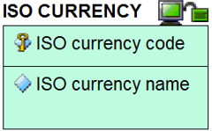

The third type is a **relationship**, or ‘foreign key constraint’. The lines between entities with the different symbols represent the different variants there are to these relationships. The relationships include ‘one to one’, ‘one to many’ and ‘many to many’ but the exact relationship between the connected entities is described in words with a connecting phrase such as “qualifies the price of” or “is used by” or “contains allowed values for”. This connecting phrase will be contextual depending on the entities involved.

The variants of relationship differ from each other in other aspects:

|  |  |
| --- | --- |
|  | **Variant one:** The identifier of the first entity is passed as a non-identifying element of the other entity. |
|  | **Variant two:** The identifier of the first entity is passed as an identifying element of the other entity. The line between the two entities is a solid line. |
|  | **Variant three:** Many-to-many relationships. These typically require an intermediate entity to clarify the constraints |
|  | **Variant four:** Subtyping – where multiple entities have the same identifier, but the subtypes need distinguishing from each other because they have different attributes. |

For further instructional material on how to read the CFIHOS Data Model, refer to the Data modelling Training Material [C-DM-901] on the CFIHOS SharePoint site.

For reference within the figures below, the following colour coding represents the source of the information:

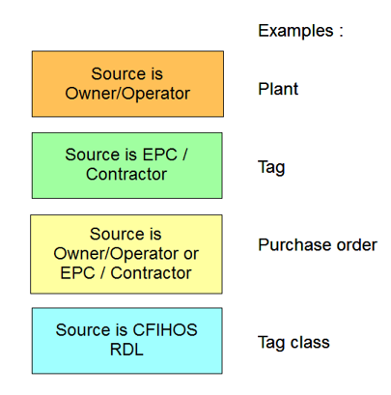

* + 1. High-level views of the CFIHOS data model

This section provides examples from the CFIHOS data model. In order to understand the context of the entities that make up a capital facility and all the elements that are required in the handover of information, the following four extracts from the overall data model cover the key areas.

It is important to appreciate that even extracts of specialist areas of the model – e.g. the part covering documents and document metadata – is always a part of a bigger picture and the entities covered in one picture with the same name as those covered in another picture are, by definition, the same.

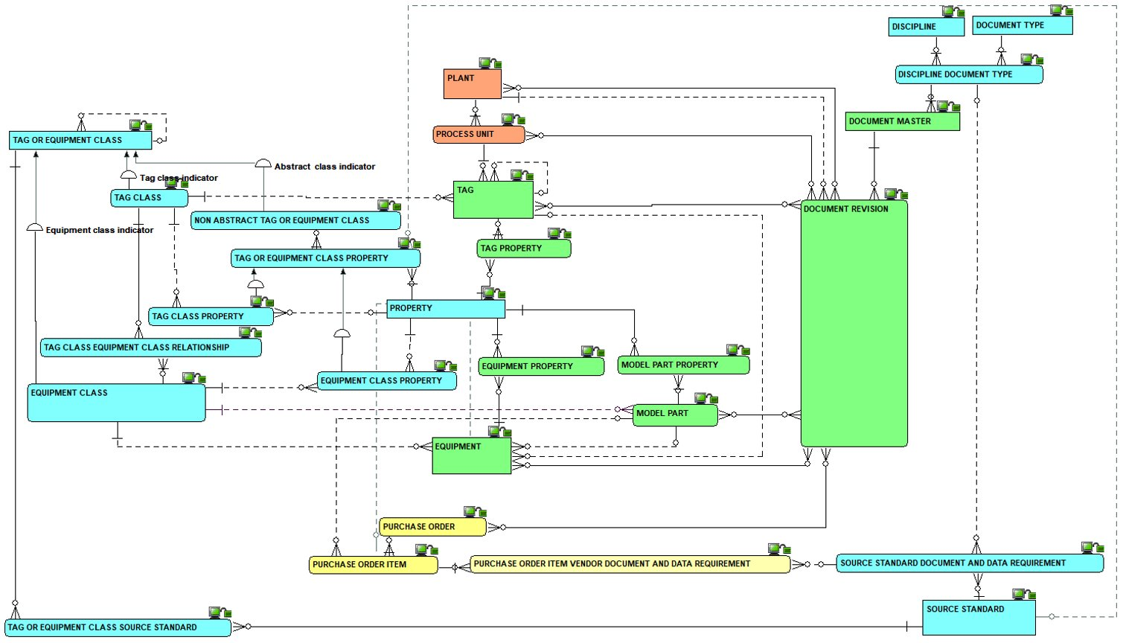

Figure 1 - High-level overview of the complete model

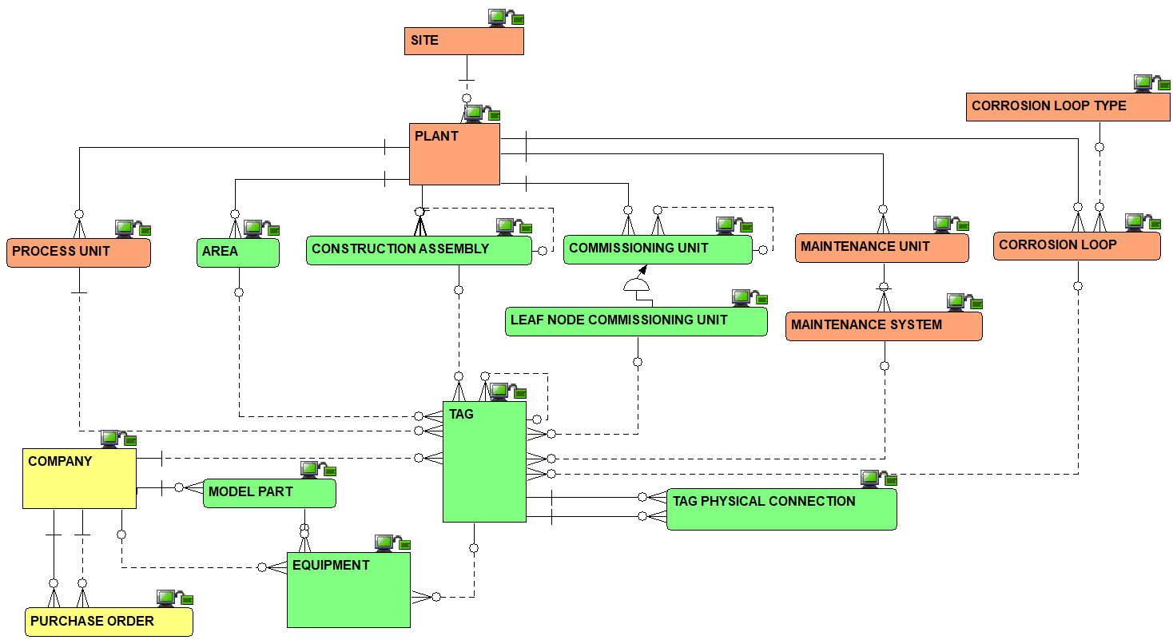

Figure 2 - Overview of the Plant Breakdown Structure

Figure 3 - Overview of the Classifications and Properties including Processes, Streams and Cases

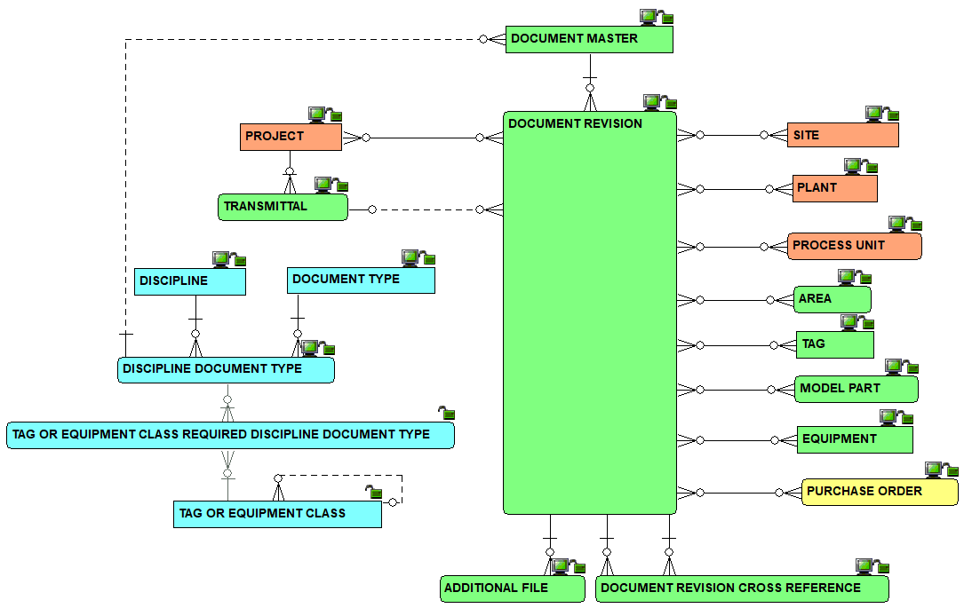

Figure 4 - Overview of the document management metadata

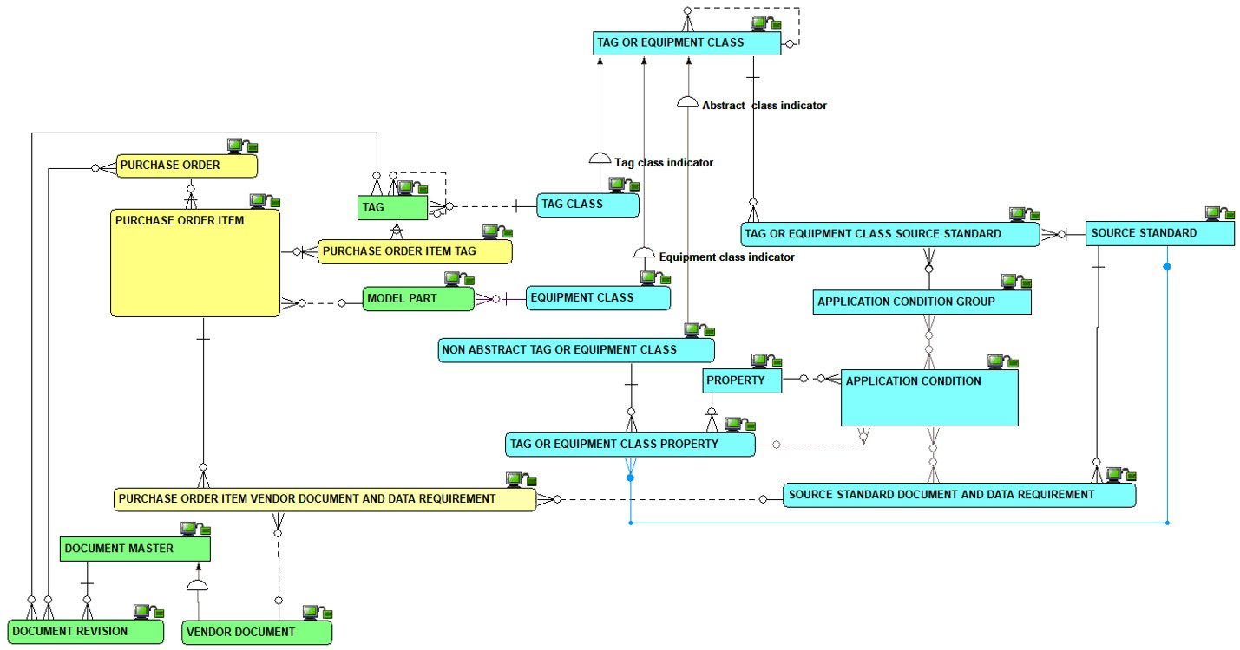

Figure 5 – Overview of metadata requirements at time of procurement

* + 1. Complete set of views of the CFIHOS data model

The complete data model is available in the following formats:

* As a PowerPoint slide
* In its native format.

Note – both of the versions come under the same document number [C-DM-001].

* 1. Data Dictionary
     1. How to understand the data dictionary

For each CFIHOS Entity Object the data dictionary provides the list of attributes, with their definitions, examples, formats, optionality, constraints and sources.

Table 2 describes the content of each column in the data dictionary.

Table 2 - Data Dictionary Descriptions

|  |  |  |
| --- | --- | --- |
| Column | Field Name | Definition |
| A | Section | Provides a unique reference to each entity, with some mapping to the section used in the previous edition. NOTE. This column is not shown in the light version of the data dictionary, as it is replaced by the name of the related Entity for filtering. |
| C | Name | The name of the entity (in the physical world: table) or attribute (in the physical world: column) |
| D | Definition | What the entity or attribute is/means/represents |
| E | Note/ comment | Supplementary information about the entity or attribute, though not part of the definition |
| F | Example | An example to assist in understanding. |
| G | Identifier/ Mandatory/ Optional | An indication whether the attribute is (part of) what identifies one occurrence of the entity, or, if not (part of- the identifier, whether the attribute is mandatory or optional |
| I | Format | An indication of attribute’s data type and its maximum size |
| J | Constraint | An indication of restrictions on allowable values of the attribute |
| K | CFIHOS unique id | A code that, in CFIHOS, identifies uniquely an entity or an attribute. (Note: this column is not shown in the light version of the data dictionary) |
| L | Data source | An indication of where the data is sourced from:   * Principal * Contractor/Supplier/manufacturer * A mix of both * Reference Data Library (RDL) * RDL as a pick list (note that the RDL pick list records are not shown in the light version of the data dictionary) |

* + 1. CFIHOS Data Dictionary excerpt

Excerpt of the CFIHOS Data Dictionary provided below for reference:



* + 1. Access to the CFIHOS Data Dictionary

The complete CFIHOS Data Dictionary can be found in document C-DM-002.

A lighter version of the data dictionary, which omits columns K and L (see above) is also available.