CFIHOS - Scope and Procedure

Acknowledgements

In 2012, Shell approached Netherlands-based process industry organization USPI to explore turning their corporate information standard into an industry-wide standard. The result was the CFIHOS (Capital Facilities Information Handover Specification) project.

Its aim is to offer practical, standardized specifications for information handover that work across the supply chain – operators, contractors and suppliers. The most recent CFIHOS industry standard (Version 1.4) was published in October 2019 by USPI with support from the Engineering Advancement Association of Japan (ENAA). This document, describing the scope and procedures of CFIHOS, is part of this standard.

Following a member vote in 2019, the future governance, development, and maintenance of the CFIHOS project and standard moved from USPI to IOGP in January 2020, becoming Joint Industry Project (JIP)36.

Disclaimer
Whilst every effort has been made to ensure the accuracy of the information
contained in this publication, neither IOGP nor any of its Members past present or
future warrants its accuracy or will, regardless of its or their negligence, assume
liability for any foreseeable or unforeseeable use made thereof, which liability is
hereby excluded. Consequently, such use is at the recipient’s own risk on the basis
that any use by the recipient constitutes agreement to the terms of this disclaimer.
The recipient is obliged to inform any subsequent recipient of such terms.
This publication is made available for information purposes and solely for the private
use of the user. IOGP will not directly or indirectly endorse, approve or accredit the
content of any course, event or otherwise where this publication will be reproduced.

Copyright notice
The contents of these pages are © International Association of Oil & Gas Producers.
Permission is given to reproduce this report in whole or in part provided (i)
that the copyright of IOGP and (ii) the sources are acknowledged. All other rights are
reserved. Any other use requires the prior written permission of IOGP.
These Terms and Conditions shall be governed by and construed in accordance
with the laws of England and Wales. Disputes arising here from shall be exclusively
subject to the jurisdiction of the courts of England and Wales.

CFIHOS - Scope and Procedures

Version | Date | Comments/History
1.4 | April 2020 | IOGP republication of CFIHOS document first published in October 2019.
1.4.1 | December 2020 | Minor text changes in Section 5: ‘General Concepts and Principles’ to ensure continued alignment - following bug fixes to the CFIHOS Standard. The changes affect sub-points:  5.4.2.3, 5.4.2.6 and 5.4.2.7,  5.4.3.1 and 5.4.3. 6  5.5.3.5  Change to Section 7: IT requirements  7.4 - suppliers defined to align with specification document

Foreword

The Capital Facilities Information Handover Specification (CFIHOS) is an industry standard developed to improve how information is exchanged between the companies who own, operate, and construct equipment for the process and energy sectors. Starting with a common equipment naming taxonomy and supporting specifications, its goal is to become a common language for the exchange of information in these sectors.

The initial focus is on information, both structured data and traditional document formats, which must be handed over when a project moves from its development to operations phase. Ultimately, the aim is for CFIHOS to become the de-facto standard for information exchange throughout the physical asset lifecycle, from vendor information through to decommissioning.

The Reference Data Library or “RDL” lies at CFIHOS’ heart. This library gives a standard and unified naming convention for equipment, its attributes, disciplines, and documents. Version 1.4 of the CFIHOS RDL includes:

- A list of classes for Tag and Equipment (what the equipment does and what it is)
- A list of properties (attributes, measures, characteristics etc.)
- Lists of requirements by class (data and document requirements)
- Standard unique coding of data to facilitate digital design and other workflows
- A list of document types
- A list of disciplines

At present, CFIHOS covers only the exchange of structured data and documents - not graphical, geometry, and model data. In the future, CFIHOS could be extended to include graphical and design tool and support spare parts procurement, inspection, test requirements, commissioning check sheets, Work Packaging, configuration management, and even drive payment.

CFIHOS is being developed collaboratively by project members as a practical standard to ensure the systematic and reliable exchange of information between all participants involved in the information supply chain, thereby reducing cycle times and costs. More than 70 organizations contributed to the development of CFIHOS Standard version 1.4, which is supported by several leading software industry design tools.

Contents
Foreword 4
1.1 General 8
1.2 Scope 8
1.3 Documents Structure 8
2. Normative References 9
3. Terms and Definitions, Acronyms and Abbreviations 9
4. Information Management Standards 11
4.1 General 11
4.2 Applicable Regulations and Standards 11
4.3 Project Reference Documents 11
5. General Concepts and Principles 11
5.1 General 11
5.2 Maturity of Information 11
5.3 Information Life Cycle 11
5.3.1 Information Suppliers and Information Consumers 12
5.3.2 Information Supply Chain Requirements and CFIHOS 13
5.4 Capital Facility Information 14
5.4.1 General 14
5.4.2 Capital Facility Documents 15
5.4.3 Capital Facility Data 16
5.5 Information Security 17
6. Information Management 18
6.1 Management of Data, Information, and Documents 18
6.2 Project Information Management Implementation Plan 18
6.3 Information Quality Management 18
6.4 Information Security Management 19
6.5 Facility Information Management 19
6.5.1 Scope of Facility Information Management 19
6.5.2 Facility Document Management 19
6.5.3 Facility Data Management 21
6.5.4 Data and Document Consistency Management 22
6.6 Change Management 22
6.6.1 Document Change Management 22
6.6.2 Data Change Management 23
6.7 Interface Management 23
6.7.1 Correspondence Management 23
6.7.2 Tie-Ins, Boundaries and Scope Management 23
6.7.3 Workflow Principles 23
6.8 Data/Information Governance 23
7. IT Requirements 24
7.1 Common Data Environment (CDE) 24
7.2 Applications used by Contractor 24
8. IM Organization, Roles, and Responsibility 24
8.1 Stakeholders 24
8.1.1 Corporate Stakeholders 24
8.1.2 Internal Stakeholders 25
8.2 Information Interfaces among Stakeholders 26
8.3 Information Review and Approval Responsibilities 26
8.4 IM Organizations and Functions 27
8.4.1 Principal’s IM Organization 27
8.4.2 Contractor’s IM Organizations 27
8.4.3 Suppliers/Manufacturers’ and Subcontractors’ IM Organizations 27
8.4.4 Joint IM Team 27
8.5 IM Roles, Job Descriptions, Responsibilities, and Skill Sets 27
8.5.1 General 27
8.5.2 IM Roles 27
8.5.3 Data Owners and Data Stewards 28
9. Information Management Process and Activities 28
9.1 Information Management Process Overview 28
9.2 Pre-Bidding Phase 29
9.2.1 Information handover requirements in the Contract 29
9.2.2 IM related documents to be produced by Contractor 29
9.2.3 Consistency among the Contracts 30
9.3 Bidding, Bid Submission, and Evaluation Phase 30
9.3.1 Clarifications and answers 30
9.3.2 IM related deviations and alternatives 30
9.4 Upon Contract Award 30
9.4.1 Adjustment of CFIHOS requirements 30
9.4.2 Project Dictionary and Classification 30
9.4.3 Provision of Model Configuration Files 30
9.5 EPC Phase 30
9.5.1 Kick-off Meeting and regular meetings 30
9.5.2 Submission of Contractor’s IM related documents 31
9.5.3 Data Management and Data Governance Activities 31
9.6 Upon Contract Completion 31
9.7 During Operation and Maintenance 31
9.8 Decommissioning of Plant 31
10. Bibliography 31
Annex A: Building Information Modelling 32
A.1 General 32
A.2 Project Information Model - Work in Progress 32
A.3 Asset Information Model – Archives 32
A.4 Common Data Environment (CDE) 32
Annex B: Transmittal 32
B.1 General 32
B.2 Components in a Transmittal 32
B.3 Transmittal and Transmission Options 32
B.3.1 Transmittal Options 32
B.3.2 Transmission Method Options 33
B.4 Examples 34
B.4.1 Combinations of Transmission Options 34
B.4.2 Example 1 34
B.4.3 Example 2 35
Annex C: IM Job Description 37
C.1 Information Management Roles and Job Description 37
C.2 Information Management Lead 37
C.2.1 Main Functions 37
C.2.2 Tasks and Responsibilities 37
C.2.3 Required Skill Sets and Experience for the Contractor’s Information Management Lead 37
C.3 Document Control Lead 38
C.3.1 Main Functions 38
C.3.2 Tasks and Responsibilities 38
C.3.3 Required Skill Sets and Experience for the Contractor’s Document Control Lead 38
C.4 Data Control Lead 38
C.4.1 Main Functions 38
C.4.2 Tasks and Responsibilities of the Contractor’s Data Control Lead 39
C.4.3 Required Skill Sets and Experience for the Contractor’s Data Control Lead 39
Annex D: Figures and Tables Lists 40

1. Introduction

General
The CFIHOS Scope and Procedure describes how to execute Information Management activities to support an efficient delivery of CFIHOS requirements, including “who” (roles, responsibilities, and required skill sets) to do what (deliverables defined in CFIHOS Specification Document) and “when” and “how” they must be conducted. This document is intended to be utilized by Principal and/or Contractor as a reference to create the project specific Information Management Scope of Work.

Since each project has different requirements depending on its size, scope, complexity, and delivery schedule, not all topics in this document will apply to an individual project. This document may be used as a check list, a template, or a repository for contract language to be included in a contract scope of work or coordination procedure.

When using this document, it is recommended that the documents listed in 2.0 Normative References should be read and understood together.

Scope
This document covers:

- Incorporation of CFIHOS into a Contract’s Information Management or Handover Scope of Work;
- Incorporation of CFIHOS into a Contract’s administration instructions or coordination procedures.

Out of scope of this document:
- Intellectual Property;
- Copyright;
- Export Controls;
- General Data Protection Regulation (GDPR).

Documents Structure
CFIHOS Documents are organized as shown in Figure 1. This document is indicated by the red circle.
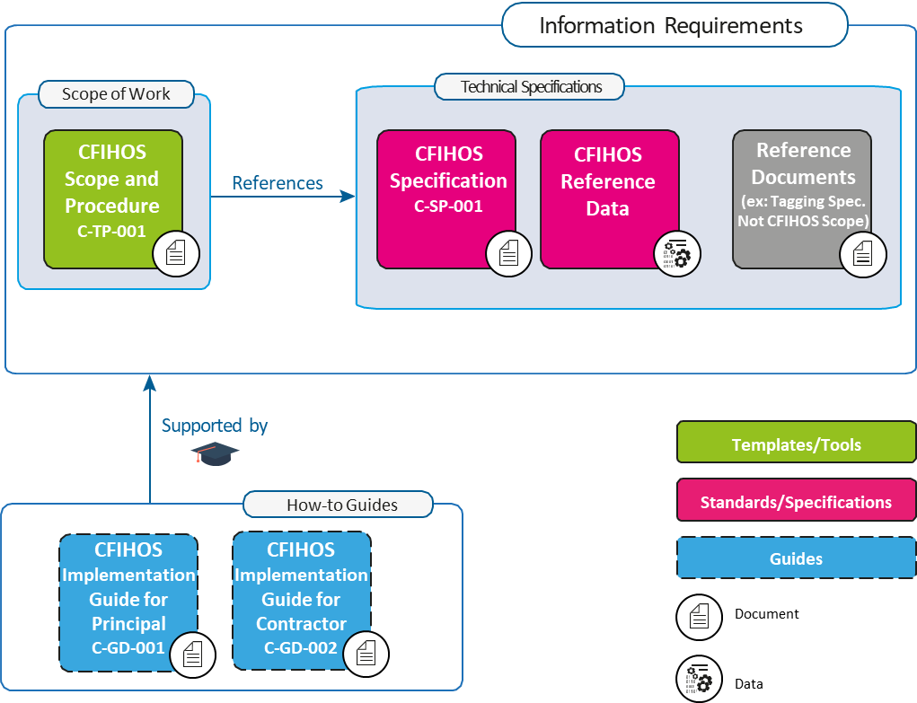
Figure 1: CFIHOS Document Structure

Normative References

- CFIHOS Specification Document [C-SP-001];
- CFIHOS Implementation Guide for Principal [C-GD-001];
- CFIHOS Implementation Guide for Contractor [C-GD-002].
- CFIHOS Reference Data Library [C-ST-001]
- CFIHOS Data Dictionary [C-DM-002]

Terms and Definitions, Acronyms and Abbreviations

The terms used in this document are included below.

As-Built Information is the information (data and documents) accurately reflecting the physical plant at the time of the plant handover.

AIM: Asset Information Model - Information reflecting as-built plant (see A.3).

BIM: Building Information Modelling (BIM) is a digital representation of physical and functional characteristics of a facility.

CDE: Common Data Environment (refer to BS1192) is a concept to share, review, publish and maintain the data and the documents. CDE is meant to achieve the ‘Single Source of Truth’ principle, though it may be built physically by using multiple IT environments such as EDMS and multiple databases.

Capital Facility Information is the information required to build, operate, and maintain the capital facilities, including data and documents. CFIHOS defines such information.

Contract Information Management Scope of Work: In this part of a contractual document, Principal specifies the terms and conditions for information delivery by Contractor. Where it is applicable and feasible, quality benchmarks and criteria to fulfil may be included. For any details there could be either referred to specific specification documents or included in the scope of work.

Contract Information Specification (CIS): The resulting document when CFIHOS is applied to a particular project describing the explicit set of requirements to be fulfilled. Linked to this document is a Reference Data Library that describes the data characteristics and document types. CFIHOS Specification Document [C-SP-001] is the basis for creating a Contract specific Information Specification.

Contractor is the party that carries out all or part of the design, engineering, procurement, construction, commissioning or management of a project or operation of a facility. The Principal may undertake all or part of the duties of the (EPC) Contractor.

CSV: Comma Separated Values, rows of plain text data values in columns separated by commas.

Data is the raw material of information.

Data Governance is a concept and a set of activities that oversees the data/information management or document management carried out to satisfy the requirements of CFIHOS.

Data Management is a concept and a set of activities to manage data, information, and documents, including but not limited to the knowledge areas of data architecture, data security, metadata, data quality, data integration, master and reference data, document control, and data handling ethics.

Data Model is the visualized data structures, following the notations such as IDEF-1X or IE. Data Models include part of Metadata.

Data Owner is a person responsible for the data quality and belongs to an organization which produces or obtains the data.

Data Steward is a guardian responsible for review and monitor the data quality issues and works closely with Data Owners and IM organization.

Document is in a general sense, a container of data and information, typically includes engineering deliverables and drawings, purchase orders, inspection records and so on.

Document Issue Purposes indicate the purposes of document issues, such as for information, for review and comments or for approval.

DCS: Distributed Control System is a computerised control system for a plant, where autonomous controllers are distributed throughout the system, but with central operator supervisory control.

EDMS: Electronic Document Management System is a software programs used to track, manage and store electronic documents.

EPC: Engineering, Procurement, and Construction (EPC) is a form of contracting arrangement used in capital facility industries where the EPC Contractor is responsible for all the activities from design, procurement, construction, commissioning and handover of the project to Principal.

Equipment is a physical device designed to perform certain functions.

FTP: File Transfer Protocol (FTP) is a standard network protocol used for the transfer of computer files between a client and server across a computer network.

Graphical Data is data intended to show graphical or geometric information such as location, elevation, size, height, and used for CAD (Computer Aided Design).

Information is Data in context.

Information Consumer is a party who defines, receives, and consumes information.

Information Life Cycle is the life cycle of various pieces of information which is defined, designed, created, used, handed over, and eventually disposed of.

Information Management (IM) is the management of data, information and documents to satisfy the CFIHOS requirements and the Contractor’s own information needs. In CFIHOS, Information Management and Data Management are used interchangeably.

Information Supplier is a party who supplies information according to the requirements defined by Information Consumer,

Information Supply Chain is the chain of information supplied and consumed between Information Suppliers and Information Consumers.

IT: Information Technology (IT) is the use of computers to store, retrieve, transmit, and manipulate data or information.

ITB: Information To Bid (sometimes called ITT - Information To Tender) is an invitation to prospective contractors or suppliers to submit a bid, in the form of a packaged document describing contract conditions and specifications.

Master Document Register (MDR) is a single complete list of documents that contains document metadata which is shared among the relevant parties.

Master Tag Register (MTR) is a single complete list of the tags used for the facility, which is shared among the relevant parties.

Non-graphical Data is data conveyed using alphanumeric characters (as defined by PAS 1192-2:2013). In CFIHOS, Non-graphical Data means all the data except the Graphical Data (see above).

Owner/Operator or Principal is a party who initiates the project, owns and operates a plant, and ultimately pays for it. Owner/Operator may also include an agent or consultant authorised to act for, and on behalf of, Owner/Operator.

Packaged Equipment is equipment composed of multiple sub-components such as s compressor, a gas turbine, etc., typically engineered by specialty equipment Suppliers/Manufacturers.

PDF: Portable Document Format (PDF) is a file format developed by Adobe to present documents, including text formatting and images, in a manner independent of application software, hardware, and operating systems.

PIM: Project Information Model - information still work in progress and subject to change (see A.2).

RDL: Reference Data Library of the metadata of Data and Documents described in CFIHOS Reference Data Library [C-ST-001];

Subcontractor is a company or person who is hired by Contractor to perform a specific task as part of the overall project.

Supplier/Manufacturer: Refer to CFIHOS Specification Document [C-SP-001]

Tag is a decomposition of a “high-level” Process Unit function into more granular “subfunction”.

Web API is application programming interfaces implemented in web server;

WORK: Works specified in the Contract Scope of Work.

Work Packaging (WP) is a subset of a project that can be assigned to a specific part for execution.

Information Management Standards

General
During its performance of the WORK, Contractor shall comply with the following requirements, standards, and any other specific Principal’s instructions associated with the WORK.

Applicable Regulations and Standards
Unless defined otherwise in the contract, the order of precedence for requirements and standards shall be:
- Regulatory requirements;
- Contract Information Management Scope of Work and the related CFIHOS Information Specification, including pre-award correspondence, clarifications and notes of pre-selection, and pre-award meetings, which have been incorporated into the Contract;
- National standards;
- Regional standards;
- International standards;

Project Reference Documents
Contractor shall follow relevant project reference documents including but not limited to:
- Tag Numbering Specification;
- Document Numbering Specification;
- Correspondence Management Procedure;
- Technical Queries Management Procedure.

General Concepts and Principles

General
There are general principles and requirements when Information Management is executed. It is important that Contractor and Suppliers/Manufacturers understand the general concepts and principles described in this section so that the parties involved in the CFIHOS framework have efficient communication based on the common vocabularies and definitions.

Maturity of Information
The information related to Capital Facilities is categorised in Table 1 (see also A.1 BIM) and the information under the CFIHOS scope is shown in the cells. Though Graphical data is currently out of CFIHOS scope, Principal may request Contractor to submit data or documents extracted from engineering tools which handle graphical data. Such data and documents shall be regarded as those within CFIHOS scope.
Table 1: Maturity of Information and CFIHOS

 | Document | Non-Graphical Data | Graphical Data
Project Information Model | CFIHOS* | CFIHOS* | Currently  Out of Scope
Asset Information Model | CFIHOS | CFIHOS | Currently  Out of Scope
*Only those required in the Contract

While Principal ultimately requires an Asset Information Model (As-Build Information), Contractor sometimes carries out concurrent engineering, procurement, and construction work so that information produced in the engineering phase may be altered in subsequent phases where Project Information is produced. Principal can instruct Contractor to submit such information so that Principal can start the process of the Information Management during the EPC phase.

The Project Information Model may also include information which is only required for EPC work such as resources utilised to build the plant, temporary facilities and machineries, and the progress of work, which are currently out of the CFIHOS scope.

Information Life Cycle
Like any asset, Information has its own life cycle. To produce, exchange, and maintain high-quality information, the whole life cycle should be managed starting from the information requirements definition through design and implementation, human operations, storage and maintenance, audit and governance and hand over. The information is eventually disposed of when it is no longer required. The management of this life cycle is an essential part of Information Management.

CFIHOS plays the central role in Information Supply Chain because it defines Information Consumer’s needs, which are ultimately the Principal’s information requirements, with the expectations that such information is delivered by Information Suppliers.

The information produced or collected by one party may be handed over to other parties (external organizations or internal organizations) to be processed, used, and subsequently handed over to yet other parties. This creates the Information Supply Chain.

The Information Life Cycle and the Information Supply Chain are closely related in terms of:

- Who defines the information requirements;
- When and how the requirements are defined and handed over to Information Supplier;
- Where and by whom the information is created, processed and maintained;
- When and how the information is handed over from who to who;
- Who is involved in information quality assurance and where, when, and how it is conducted;

The life cycle processes are shown in Figure 2 and Table 2.

Information Suppliers and Information Consumers
When information is handed over from one party to another, the party who supplies the information is called Information Supplier and the party who receives the information is called Information Consumer.

In EPC Contracts, the Principal is Information Consumer and the Contractor is Information Supplier.

When a Contractor requests data from its Subcontractors and/or Suppliers/Manufacturer, Contractor becomes Information Consumer, and the Subcontractors and the Suppliers/Manufacturers are Information Suppliers.

It is important to note that, unlike other physical assets, Information is a type of asset which does not deteriorate even if it is used. For example, the information that Information Suppliers produce can be used by parties other than the intended Information Consumer. CFIHOS however focuses on the data usage by Principal who specify the data and document requirements, not by other parties.

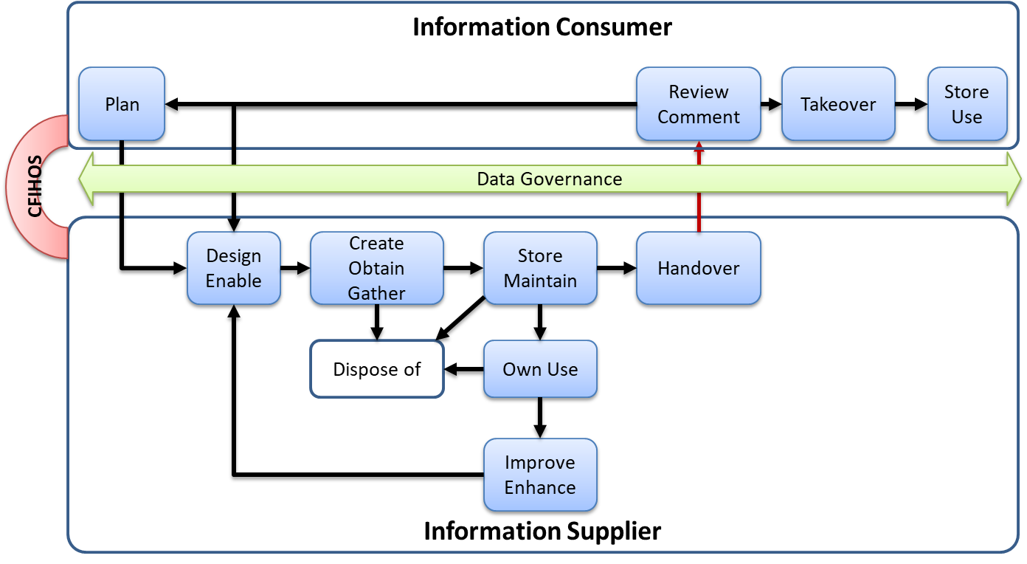
Figure 2: Information Life Cycle with Information Supplier and Information Consumer

Table 2: Information Life Cycle Process

Life Cycle Process | Responsible Party | Process Description
Plan (Requirements) | Information Consumer | Defines and provides requirements to Information Supplier
Design and Enable | Information Supplier | Design the process to fulfil the requirements. This process is typically explained in the Information Supplier’s documents such as IM Plan and Procedures.
Create, Obtain or Gather | Information Supplier | Actually creates information or obtains/gathers information from other parties.
Store and Maintain | Information Supplier | The information created, obtained or gathered is stored and maintained in CDE.
Hand Over | Information Supplier | The information requested by Information Consumer is handed over to the Information Consumer.
Own Use | Information Supplier | The information stored and maintained by Information Supplier may be used for its own purposes or used and processed to produce the Information required by Information Consumer.
Improve and Enhance | Information Supplier | The quality of the information which Information Supplier stored and maintained may have to be improved by reviews and assessment of the related processes.
Hand Over | Information Supplier | The information created, obtained, and gathered is handed over to Information Consumer
Review and Comment | Information Consumer | The information handed over to Information Consumer is reviewed against the information requirements in the CIS. If the information does not meet the requirements, Information Consumer provides comments to Information Supplier for improvements.  Note: The deficiency of the Information can be caused by the deficiency in the Information requirements specified by Information Consumer, in which case Information Consumer should improve the requirements (Plan process)
Takeover | Information Consumer | After the information passes the review process and is accepted, it is taken over by Information Consumer.
Store and Use | Information Consumer | The information is stored in Information Consumer’s CDE and used for its purposes.
Dispose of | Information Supplier | The information stored and maintained by Information Supplier may become obsolete or useless if it is overridden or found defective, in which case Information Supplier may dispose of the information.

Information Supply Chain Requirements and CFIHOS
Within the Information Supply Chain, Information Consumers and Information Suppliers have a binding contract, following the CFIHOS framework (CFIHOS compliance contract or CFIHOS equivalent contract*). The data and documents are handed over through the Information Supply Chains based on such contracts. In many cases, one party plays both roles when that party receives information from other parties and hands the information over to yet another party (see Figure 3).

The whole Information Life Cycle process shall be managed and audited with data/information governance activities to ensure the Principal’s Information Requirements are fulfilled. When information quality is found unsatisfactory at the time of the information hand over, recovery and rectification will be required by re-definition, re-design, re-work, and re-submission of the information. All stakeholders including Principal, Contractor, Subcontractors, and Suppliers/ Manufacturers shall be aware of the Information Life Cycle and Information Supply Chain concepts to ensure proactive approach at delivering quality information within allocated project resource hours, cost, and schedule.

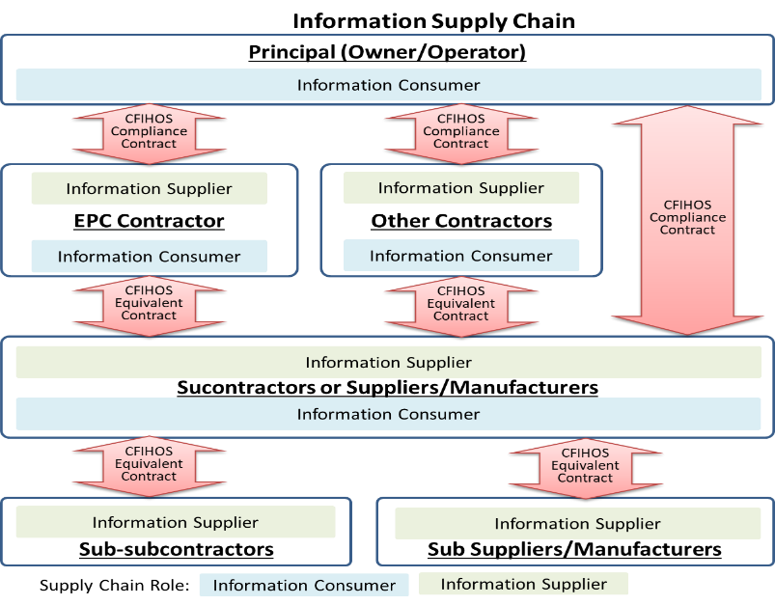
Figure 3: Information Supply Chain

* The difference between CFIHOS compliant contracts and CFIHOS equivalent contracts: While Principal and Contractor have a CFIHOS compliance contract (CIS) following “Implementation Guide for Principal (C-GD-001)”, in subcontracts, Contractor may modify the CIS requirements to suit the Contractor’s needs or with consideration to the capabilities of Suppliers/Manufacturers or Subcontractors, in which case CFIHOS equivalent contracts are used.

Capital Facility Information

General
Capital Facility Information includes data and documents required for facility operation and maintenance. In this section, the concepts and principles applied to data and document management are discussed respectively. Further guidance on the relationship between data and documents can be found in the CFIHOS Implementation Guides [C-GD-001, C-GD-002].

- Document Metadata: Documents themselves are described, classified, and managed by data as described in Document Management section 4.4.2;
- Information Metadata: Metadata to define the information by its definitions, formats, relationships, the value ranges (see CFIHOS Specification Document [C-SP-001]);
- Consistency between Data and Documents: Documents contain Data as their contents. For example, Tag numbers exist in documents as well as in data sets. Consistency should be ensured within Documents, among Documents, and between Documents and Data as described in Information Quality Management section 6.3;
- Data Transmission: The collection of data can be presented and transmitted as documents – see Annex B.

Capital Facility Documents

Scope of the Capital Facility Documents
Capital Facility Documents include but are not limited to the following:
- Project Plans and Procedures;
- Engineering deliverables, including those supplied by Supplier/Manufacturers;
- Engineering documents;
- Engineering drawings;
- Procurement related documents;
- Construction related documents;
- Commissioning related documents;
- QA and QC related documents;
- Any other documents required by Principal.

Please refer to the CFIHOS RDL [C-ST-001] for details.

Master Document Register (MDR)
Principal and Contractor shall agree to, update, maintain, and share a single MDR containing all the project document deliverables.

Please refer to the CFIHOS Specification Document [C-SP-001], CFIHOS RDL [C-ST-001], and the CFIHOS Data Model [C-DM-001] for the detailed structure of the MDR.

Contractor shall:
- Issue the first version of MDR to Principal for review and approval by Principal within thirty (30) days of the contract commencement date unless otherwise specified in CIS.
- Maintain and issue the revised MDR to Principal whenever the MDR is updated.
- Issue and transmit documents in accordance with the latest MDR by following the Document Number, Document Title, and Revision Number in the MDR.

Document Properties (Metadata)
All Documents shall be accompanied by their Document metadata as described in CFIHOS Specification Document [C-SP-001].

Document Index
When multiple files constitute one document (e.g., multiple renditions) the transmittal shall contain a document index file.

Document Templates
The Document template for each category of document type shall be proposed by Contractor and shall be approved by Principal at the beginning of the Project. Contractor shall use the approved document templates including but not limited to
- Engineering Documents (Philosophies, Procedures, Specifications)
- Engineering Drawings
- Engineering Data Sheets
- Correspondences
- Meeting Minutes
- Change Orders

Document Specific Requirements

Encryption and Password Requirements
Principal shall state within the security requirements if the documents shall or shall not be encrypted with passwords when submitted. If they are encrypted with passwords, Principal and Contractor shall agree on how to handle the passwords.

File Compression and Packaging Requirements
Principal shall state if the document(s) whether a single file or multiple files shall be compressed and packaged (namely “zipped”) or not as well as their electronic package file naming conventions.

Archiving Requirements
For document archive requirements, Contractor shall follow the specifications provided in CFIHOS Specification Document [C-SP-001].

Information Relationship Requirements
The information relationships requirements such as Tag to Document, Tag to Tag, Document to Document, Document to Equipment, and Document to Area are specified in CIS and Contractor shall include the implementation plan to achieve such requirements in Contractor’s Information Management Plan (see 6.2).

Principal shall state which relationships and which information types are subject to these requirements.

Capital Facility Data

Tags and Equipment
Tag represents a specific function in a Plant with its logical location identified by a Tag number. Therefore, the properties of Tag are function related. Equipment represents a physical asset to satisfy a certain function represented by Tag. Therefore, the properties of Equipment are asset related properties such as a serial number and a manufacturer and actual purchase date.

Types of Tags can be categorized into the following:
- Tags without equipment – sometimes called as soft tags, such as DCS tags;
- Tags attached with equipment – sometimes called as hard tags;

It is important for Principal and Contractor to recognize the one-to-many relationships between Tag (one) and Equipment (many) to express scenarios such as:
- Multiple pieces of equipment can be installed to one Tag over time in the commissioning phase or the maintenance period (for example, switched or replaced with another piece of equipment). We note in such case, only a piece of Equipment is installed to a Tag at one particular point in time.
- Multiple pieces of Equipment can be installed to a Tag at the same time. Principal shall specify if this scenario is allowed in the EPC phase to keep the referential integrity;

Except in the latter case above, the Tag and Equipment relationship should be one-to-one at one time.

Principal and Contractor shall note that there are engineering tools not capable of representing the relationship between Tag and Equipment and only treating Tag and Equipment as a single entity.

Capital Facility Data Entities
Capital Facility Data is composed of the following - see CFIHOS Specification Document [C-SP-001] for more details
- Geographical Surface (Site and Area);
- Function (Plant - Process Unit - Tag);
- Plant Breakdown Structure:
- Commissioning Unit - Commissioning System – Tag;
- Maintenance Unit - Maintenance System - Tag and Equipment;
- Construction Assembly - Tag;
- Process Unit - Equipment;
- Tag Physical Connection;
- Corrosion (Corrosion Loop Type – Corrosion Loop);
- Master Data (Company, Purchase Order, Property, and Property Pick List);

Class and Properties Definitions for Tags and Equipment (Information Metadata)
Correct understanding of the data structure among Tag Class, Tag, and Tag Properties, and Equipment Class, Equipment, and Equipment Properties is essential to Capital Facility Data.

- Tag is a decomposition of a “high-level” Process Unit function into more granular “sub function”. Each Tag Class has its own set of properties. A Tag always belongs to a Tag Class. Therefore, a Tag has its own set of property values for the Tag Class properties. For example, “Pump” is a Tag Class and has designated properties such as “Maximum Design Pressure” and “Operating Pressure”. If a Tag “P-001” belongs to the “Pump” (Tag Class), then this Tag shall have property values for “Maximum Design Pressure” and “Operating Pressure”.
- Equipment is a physical device designed to perform a function. Each Equipment Class has its own set of properties. A piece of Equipment always belongs to an Equipment Class. Therefore, a piece of Equipment has its own set of property values for the Equipment Class properties. For example, “Centrifugal Pump” is an Equipment Class and has designated properties such as “Weight” and “Size”. If a piece of Equipment belongs to the “Centrifugal Pump” (Equipment Class), then this Equipment shall have property values for “Weight” and “Size”.

Master Tag Register (MTR)
MTR is the complete list of all the Tags whose information shall be handed over to Principal. MTR plays a central role in Facility Data Management and shall be delivered as structured data in accordance to CFIHOS Data Dictionary [C-DM-002].

Data Templates and Data Files
Information Consumer shall specify data templates (typically in CSV or Excel sheet formats) for Information Supplier to fill the Data in. Information Supplier shall follow the templates for the Data submission to Information Consumer. The Data packaged into Data Files are treated as Documents with designated Document Numbers, Revision Numbers, and Issue Purposes.

Data Submission, Review and Revision
Data deliverables prepared as structured data, shall be submitted, reviewed with comments and revised following similar protocols used for documents. Therefore, the data templates used to collect and submit Data deliverables shall be treated as documents. Information Consumer and Information Supplier shall follow the general concepts and principles described in section 4.4.2 when Data is exchanged.

Information Supplier shall transfer CFIHOS data by:
- Establishing a document numbering rule for the CFIHOS Data Submission in the Document numbering procedure. This document numbering shall be used for all the CFIHOS data submissions transmitted by Information Supplier. The document shall be titled "Project Name CFIHOS Data Submission"
- Allocating a number and the new revision code for the document;
- If so required in the Contract, creating a zip file to hold all the files part of the “Project Name CFIHOS Data Submission”. These files shall be formatted according to CFIHOS Specification. The set of files provided shall demonstrate the full referential integrity.

All data handed over by Information Supplier, whether intermediate or final, shall be included in a formal transmittal. Prior to submitting the formal transmittal, Information Supplier shall ensure;
- The information is numbered correctly and signed off to the appropriate level of authority.
- The correct template has been used.
- The information is structured in accordance with the Contract Information Management Scope of Work and the related specifications.

Information Security
Information Security refers to the protection of information in its broadest sense and covers access to information, protection of information against intrusion and damage and the procedures necessary to maintain the integrity of information.

Information Supplier shall ensure compliance with the Information Consumer’s Information Security requirements and ensure processes and procedures are in place to safeguard business continuity and minimize business damage.

A focus should be placed on ensuring:

- Confidentiality, protecting sensitive information from unauthorized disclosure;
- Integrity, safeguarding the accuracy and completeness of information;
- Availability, ensuring the project information and associated are available to users as required;

Information security practices shall be guided by ISO/IEC 27002. In the case of business-critical information, Information Consumer may request that Information Supplier is formally audited and certified according to ISO/IEC 27001. ISO/IEC 27001 requires management to:

- Systematically examine the organization's information security risks, taking account of the threats, vulnerabilities, and impacts;
- Design and implement a coherent and comprehensive suite of information security controls and/or other forms of risk treatment (such as risk avoidance, risk mitigation, or risk transfer) to address those risks that are deemed unacceptable; and
- Adopt an overarching management process to ensure that the information security controls continue to meet the organization's information security needs on an ongoing basis.

Information Management

Management of Data, Information, and Documents
Information Management is the management of data, information, and documents as well as relationships and consistencies among those. Information requirements described in the CFIHOS Specification Document [C-SP-001] will not simply be achieved by accident. It requires plans, controls, and assurance processes. Information Management is the development, execution, and supervision of plans, policies, programs, and practices that deliver, control, protect, and enhance the value of data and information assets throughout their lifecycles.

Information management activities are wide-ranging. They include everything from the ability to make consistent decisions about how to get strategic value from data to the technical deployment and performance of databases. Thus, information management requires both technical and non-technical (i.e., ‘business’) skills. Responsibility for managing information must be shared between business and information technology roles, and people in both areas must be able to collaborate to ensure that an organization has high-quality information that meets the CFIHOS requirements.

Project Information Management Implementation Plan
Contractor shall develop and submit to Principal for approval a Contractor Information Management Implementation Plan to satisfy the requirements described in the CIS. The Plan shall describe the following as a minimum:
- How to identify sources of data and information;
- How to create, capture, gather, and validate data and information from various sources;
- How to receive and hand over data and information across the Information Supply Chain;
- How third-party information will be managed;
- Relevant Contractor’s corporate plans and procedures;
- The use of an appropriate EDMS and procedure that is integrated with Principal’s other systems and related procedure(s);
- How to monitor and report the data and information quality;
- Contractor’s audit process for recording changes to data and information;
- The Information Management organization and scope of responsibilities
- How Contractor’s internal tools and processes shall be implemented and utilised, and how these will interface with Principal’s Common Data Environment (CDE).

Information Quality Management
Understanding of the impacts brought by poor-quality information, poor planning, siloed systems, inconsistent development processes, incomplete documentation, a lack of standards, or a lack of governance is essential. All disciplines contribute to the quality of data, not just the Information Management Team.

Formal information quality management is like continuous quality management of other assets. It includes managing information through its lifecycle by setting standards, building quality into the processes that create, transform, and store information, and measuring the quality against standards including:
- Completeness of information;
- Consistencies within Documents, between Documents, among Data, and between Data and Documents (see CFIHOS Specification Document [C-SP-001]);
- Correctness and accuracy (refer to ISO 8000, ISO 9000, and ISO 15926-4);
- Information Availability and Delivery Timing (information not available at its required time has no value).

To achieve the information quality requirements in the CFIHOS Specification Document [C-SP-001], the following shall be considered:
- Ensure the correct understanding of the metadata, including applicable data models;
- Plan and define procedures to produce, store, and maintain quality information, including human operations and IT tools and processes;
- Monitor and report information quality using metrics;
- Act on improvement measures if necessary;
- Audit information quality management by Data/Information Governance;

Information Security Management
Information security management as a minimum includes the following:
- Security by design: how to protect information by system, environment, and technology;
- Security by information handling process: how to protect information by pre-defined procedures;
- Security by human factors: how to protect information by principles and ethics;
- Actions to be taken if and when security breaches occur;
- Monitor, review, and report information security environment, activities and events;

Contractor shall propose how to achieve the security requirements described in section 5.5 with consideration of the above.

Facility Information Management

Scope of Facility Information Management
Facility Information Management includes the following:
- Facility Document Management;
- Facility Data Management;
- Data and Document Consistency Management;

Facility Document Management

General
Project documents include but are not limited to engineering documents, drawings, specifications, price-less purchase requisitions, orders and order items, inspection records and certificates including the documents from Supplier/Manufacturers and/or Subcontractors.
The Documents stored in e-files are considered as documents. Depending on the project requirements, hardcopies of documents shall also be managed. The essential components for document management are:

- Document Metadata (see CFIHOS Specification Document [C-SP-001]);
- Document Templates and Formats (see CFIHOS Specification Document [C-SP-001]);
- Discipline Document Types (see CFIHOS Specification Document [C-SP-001]);
- Master Document Register (see section 5.4.2.2 of this document)

Document Management Procedure
Contractor shall, unless otherwise specified in CIS, within thirty (30) days of the contract commencement date, develop and submit the Document Management Procedure. The Document Management Procedure describes how Contractor will manage documents in accordance with the requirements in CIS incorporating Contractor’s internal quality assurance processes.

The procedure shall include as a minimum the document numbering specification, document submission, review and approval workflows, MDR management, and supporting EDMS tool in consideration of the following:

- Compliance with the Principal’s document numbering specification.
- As-Built Documents that reflect the physical assets handed over to Principal in accordance with CFIHOS Specification Document [C-SP-001] and RDL [C-ST-001];
- Usage of a single EDMS to store and manage all the project documents;

Document Distribution Matrix
Contractor shall demonstrate appropriate and auditable document distribution mechanisms by means of document distribution matrices. Contractor shall propose, maintain, and submit the matrix to Principal for review and approval.

Timing of Document Delivery
The MDR shall be used to plan, forecast, and track the documents deliveries and statuses. Principal shall state the document turnaround durations for review, comments, and approval or rejection. The Contractor’s submission dates are the dates when Contractor delivers the documents to the Principal’s receiving device accompanied with the appropriate delivery notices issued by Contractor.

The document return dates are the dates when Principal places the documents to the Contractor’s receiving device accompanied with the appropriate delivery notices issued by Principal. In both cases, the document shall be delivered in accordance with the rules specified in the approved Document Management Procedure and each party’s document control team may reject the delivery if the rules are violated.

Document Issue Purposes and Return Statuses
Capital Facility Documents issued during the EPC phase shall be categorised by the purposes of the document issuance as follows:
- For Information: the documents are issued for information and do not necessarily require review, comment or approval.
- For Review and Comment: the documents are issued for review and comment, and Contractor may proceed with the WORK without waiting for the comments by Principal. Contractor shall however revise the documents if Principal so requests.
- For Approval: the documents are issued for Principal’s approval, in which case the document return statuses will fall into the following types:
  - Approved: documents have been approved, and Contractor can proceed with the WORK;
  - Approved with comments: documents have been approved, and Contractor can proceed with the WORK. However, Contractor shall still revise and resubmit the documents to Principal;
  - Rejected: Contractor shall revise and resubmit the documents until they are approved. Contractor shall not proceed with the WORK. Principal shall provide the reasons for the rejection to avoid repeated submissions; Principal’s rejections can occur due to the following reasons.
- Administrative reasons such as deviations from the rules stated in the approved Document Management Procedure, in which case the documents shall be re-submitted following the Procedure;
- Quality Issues (any other than the above administrative reasons).
In either case, the reasons for rejection shall be clearly stated when the documents are returned.
The approval of the documents will not relieve Contractor from the responsibilities and/or liabilities under the Contract.

Contractor’s Revisions and Re-submissions of Documents
When Contractor incorporates comments provided by Principal and revise the documents, Contractor shall
- Clearly indicate where the comments have been incorporated;
- Clearly indicate any part of documents which has been revised;
- Allocate the next revision number for re-submission

EDMS Usage Scenarios
Principal shall dictate or agree with Contractor on how the EDMS tool is used.
- Single Shared EDMS between Principal and Contractor:
If Principal agrees to use the Contractor’s EDMS, a single EDMS shall be used facing Principal even though Contractor is a joint-venture or a consortium with multiple Contractors unless otherwise specified in the Contract. Contractor shall provide the access permissions, the user manuals, and conduct the training for Principal.
- Separate EDMS for Principal and Contractor
If Principal and Contractor to use their respective EDMS, the document exchange specifications shall be provided and agreed. If the document is exchanged through file upload and download interfaces, the specifications of the Transmittal shall be agreed (see Annex B.3). Contractor shall still use a single EDMS, even in cases where Contractor is a joint-venture or a consortium with multiple contractors, unless otherwise allowed in the Contract.

Review and Comment feature of EDMS
Principal may choose one of the following scenarios for review and comment.
- Commenting on document hard-copies, scan and upload onto EDMS
- Use of PDF commenting feature and upload onto EDMS
- Multi-user concurrent reviews and comment feature of EDMS

Facility Data Management

General
Facility Data becomes part of the vital assets of Principal when the plant is operated and maintained. The data quality and delivery requirements shall be understood by Contractor.
Contractor’s approach to implementation, to achieve the requirements, shall be presented, demonstrated, and approved by Principal. Essential components of Facility Data management are:

- Metadata and data structure (see CFIHOS Specification Documents [C-SP-001]);
- Data Templates and Formats (see section 5.4.3.5 and CFIHOS Data Dictionary);
- Master Tag Register (see section 6.5.3.4)

Data Management Procedure
Contractor shall, unless otherwise specified in CIS, within thirty (30) days of the contract commencement date, develop and submit the Data Management Procedure which describes Contractor’s understanding of the requirements, how Contractor manages data in accordance with the requirements in CIS, and how Contractor’s internal quality assurance and software tools are implemented and integrated. The procedure shall specifically describe the following, as a minimum:

- How to manage Tags and Equipment data produced by Suppliers/Manufacturers and/or Subcontractors;
- How to validate Tag numbers against accuracy, format conformity, uniqueness and completeness required by CIS;
- How to consolidate all tags into Master Tag Register using Common Data Environment (CDE);
- How to maintain Master Tag Register and track changes;
- How to integrate Master Tag Register with other tools used for Contractor’s actual WORK;
- How to extract Tags and Equipment Data from Documents and other tools such as engineering tools, test and inspection tools;
- How to consolidate and deliver Data to Principal;
- How to audit and report Data Management results such as data quality issues and any rectification work required;

Classification Metadata Data Management
Classifications of data apply to the following:
- Tag Class and Tag;
- Equipment Class and Equipment;
- Model Class and Model;

It is important to note that a classification has its own set of properties (see section 4.4.3.3). Therefore, any classification changes can lead to the changes in property sets together with property values such as tags and equipment property sets and values. Since engineering tools such as 3D CAD use the same classifications, especially for Tag and Equipment classes, the impact of the change can be severe.

At the beginning of the Project, the classifications shall be provided and explained by Principal to the Contract and shall be aligned by both parties.

Master Tag Register (MTR) Management
Contractor shall create, update, and maintain Master Tag Register for their entire scope, including Supplier/Manufacturer and Subcontractor Tags, in accordance with this document and the Principal’s Tagging Specification.

The aggregation of Tag data from Contractor, and Supplier/Manufacturer and Subcontractors shall take place in a Contractor’s managed CDE. Contractor’s CDE shall be configured in accordance with CFIHOS Data Model and be used by Contractor to generate the MTR.

Unless otherwise specified in CIS, within sixty (60) days of the contract management date, Contractor shall submit to Principal an initial MTR as a deliverable.

The contents and format of the MTR shall be approved by Principal. Contractor shall update, maintain and submit the MTR to Principal regularly in accordance with the approved transfer mechanism described in Annex B.

Principal shall clearly define the scope and granularity of tags applied for the Information Handover including but not limited to the scope of:
- Hard tags (attached with equipment) and soft tags (such as DCS);
- Tags internal to package equipment;
- Pipes, cables, cable trays including their sizes;
- Control valves, manual valves, nozzles including their sizes;

Timing, Frequency and Method of Data Delivery
The timing, frequency and method of Data delivery shall be stated in CIS. The following is the typical options:
- Deliver the Data following the same procedure as the document transmittals: The timing shall be indicated in MDR;
- Delivery the Data in regular intervals, such as weekly, monthly, quarterly or using certain Project milestones. Contractor and Principal shall agree to the applicable intervals during the contract kick-off;
- On-demand delivery of Data, Principal and Contractor may decide to use Web API to push and pull data from agreed locations, in such cases, Contractor shall provide Web API specifications to Principal.

Data and Document Consistency Management
Contractor shall record and keep track of the relationships between data and documents. Contractor shall use full Tag numbers and avoid tag alias using the partial tag numbers, especially used in Documents.

Contractor shall use its best endeavour to keep consistency between MTR and the corresponding information that appears in the latest revisions of the issued documents during EPC phase. However, Contractor shall achieve the complete consistency when the As-Built data and documents are submitted.

Change Management
Since concurrent engineering processes are often carried out across various engineering disciplines, Contractor shall implement the change management to track document revisions, data creation, updates, and deletions.

Due to the nature of the concurrency, the stakeholders should understand data, information, and documents are not necessarily consistent all the time, except at as-built phase when all the data, information, and documents shall be consistent (see section 5.2).

Document Change Management
Document change management should be implemented throughout the document life cycle and involve the following aspects.
- Document Identifications: Document Number and Title Change
- Document Content Revisions: Revision Control, Content Change Tracking
- Document Workflow Statuses: Issued, Reviewed, Commented, Approved, Rejected

Data Change Management
Data change management shall be implemented throughout the Information Life Cycle. The following should be tracked in MTR:

- CUD (Create, Update, and Delete) operations logs;
- Current data status (work-in-progress, for construction, or as-built);
- Data quality status;
- Consistency among data and documents;
- Log Management;
- Tag number changes (old Tag numbers and new Tag numbers);

Where inconsistencies in the data are found, Contractor shall clearly indicate which data is the most recent and represent the latest true values.

Interface Management

Correspondence Management
Correspondences include Technical Queries, General Correspondence, and Commercial Letters. Contractor shall develop, submit and obtain approval from Principal for Correspondence Management Procedure at the beginning of the project, containing:

- Correspondence Numbering and Templates;
- Electric Correspondence Management System;
- Correspondence workflow;
- Tracking, monitor, and expediting methods

Tie-Ins, Boundaries and Scope Management
Interface Management handles the scopes and responsibilities on project boundaries such as site, services or phases which belong to different contractors, typically involving tie-ins and piping connections, a hull and top-side, or plant section physical hand over and take over. As explained in earlier chapters, various parties are involved in Information Management to satisfy the CFIHOS requirements so that Interface Management is the key to;

- Ensure common business terms and definitions;
- Avoid misunderstanding and miscommunications;
- Ensure Instructions and replies are correctly communicated;
- Exchange Data and documents correctly, securely, and promptly;
- Share Priorities, milestones, action items, and outstanding issues among stakeholders;

Workflow Principles
Especially when multiple contractors are employed by Principal and the interface management is employed, strict scoping, responsibilities, workflows, and rules shall be established.

Data/Information Governance
The Data/Information Governance process oversees various information management activities and ensures that the following questions are answered.

- Are the data requirements accurately and completely described and communicated?
- Do the data architecture, designs, and implementation plans satisfy the requirements
- Are the implementation plans feasible to produce the required Data quality?
- Is data operation based on the implementation appropriately conducted?
- Is data handover carried out based on the implementation plan?
- Are comments from Information Consumers recorded, treated and reflected to improve data quality?
- Are the whole information life cycle processes consistent, reasonable, and transparent?
- Are data quality and its improvement measured and monitored?

Data/Information Governance activities are not solely carried out by a single party, but joint efforts by all the stakeholders. Contractor shall propose how to conduct such activities and implement them with Principal.

The typical Data/Information Governance organization is shown in Figure 4 where data stewards (see 7.5.3) representing various disciplines of various companies form the governance organization. The joint Data/Information Governance committee meetings can be held once a month. How the governance is organized depends on the scale and complexity of the Project.

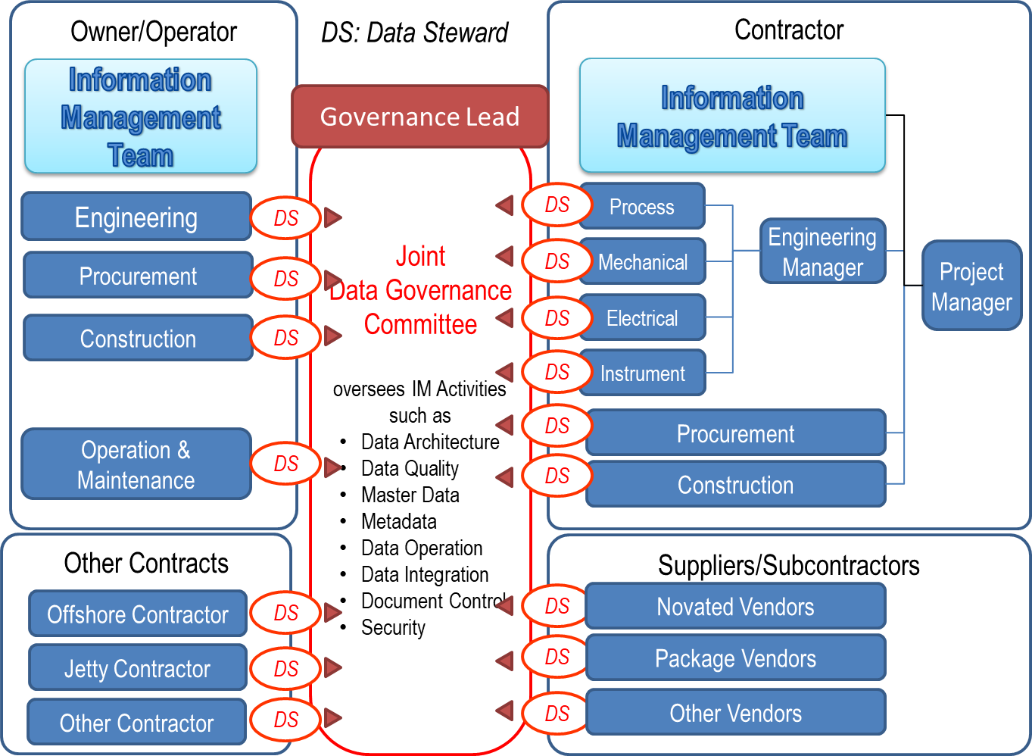
Figure 4: Typical Data/Information Governance Organization

IT Requirements

Common Data Environment (CDE)
If Principal chooses to use Common Data Environments shared with Contractor, Subcontractors, Suppliers/Manufacturers, the CDE must be identified in the contract. Proper manuals and training should be provided to those who are not familiar with the tools. (See Common Data Environment in Appendix 4)

Applications used by Contractor
Principal may mandate the use of specific software applications, versions or templates for the development and handover of deliverables; for example, a specific software application may be specified to produce documents or 2D and 3D models. Principal may host specific applications and provide remote access to Contractor. If Principal allows the use of an alternative tool, Principal shall indicate the necessary functions to be covered by the equivalent software. If Principal does not mandate specific applications or templates, Contractor has the freedom to use whatever application or template to create the requested deliverables as far as all the requirements specified in CIS are satisfied.

IM Organization, Roles, and Responsibility

Stakeholders

Corporate Stakeholders
Capital Facility contracts involve various parties who play designated contractual roles (see Figure 5). It is important to first recognise who they are and what their roles, interests, responsibilities, and concerns are. Information flows between Principal and external parties, and Principal and EPC Contractor are the two central hubs where the information flows in and out. Principal is responsible for the information exchanged with Government or Local Authorities and the Principal’s other Contractors. EPC Contractor is responsible for the information exchanged with the Suppliers/ Manufacturers and Subcontractors. It is also important to note that Supplier/ Manufacturers are directly under Contractor during the EPC phase, but they will have maintenance contracts directly with Principal after the plant hand over.

It is not recommended that Principal requests EPC Contractor to communicate directly with Government or Local authorities, or the other Principal’s Contractors unless they have the contractual relationships.

Information hand over should be considered with respect to the contractual relationships, information owners’ intellectual properties, and information provenances.
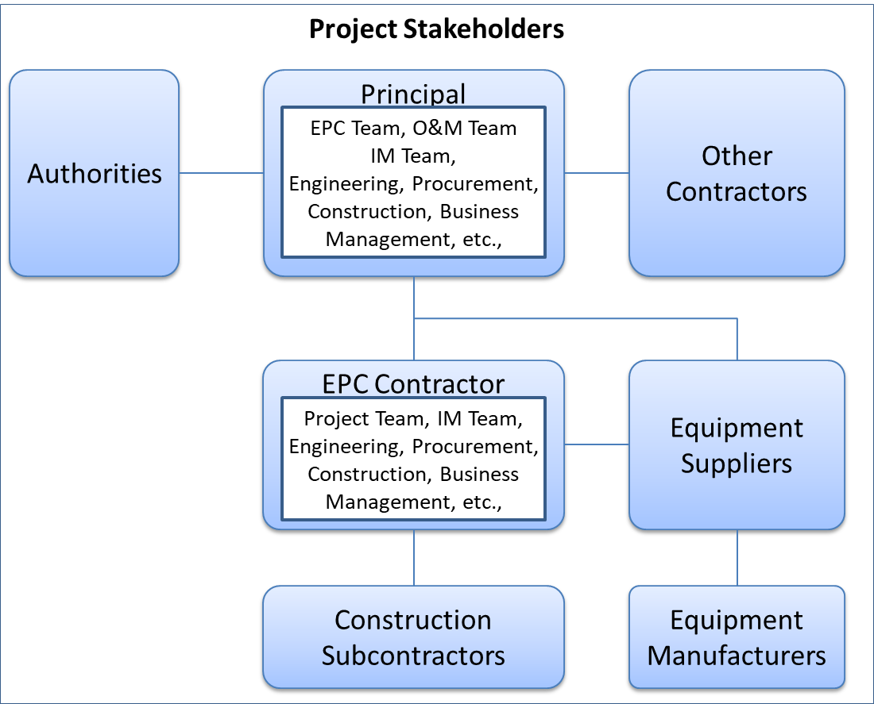
Figure 5: Project Stakeholders

Internal Stakeholders
Information Management requires the collaboration of business and IT professional and encompasses various stakeholders within Principal, EPC Contractor, and Suppliers/Manufacturer. The project organizations may be different depending on projects or corporations, but a typical relationship around Information Management Team is described as Figure 6 and Figure 7.

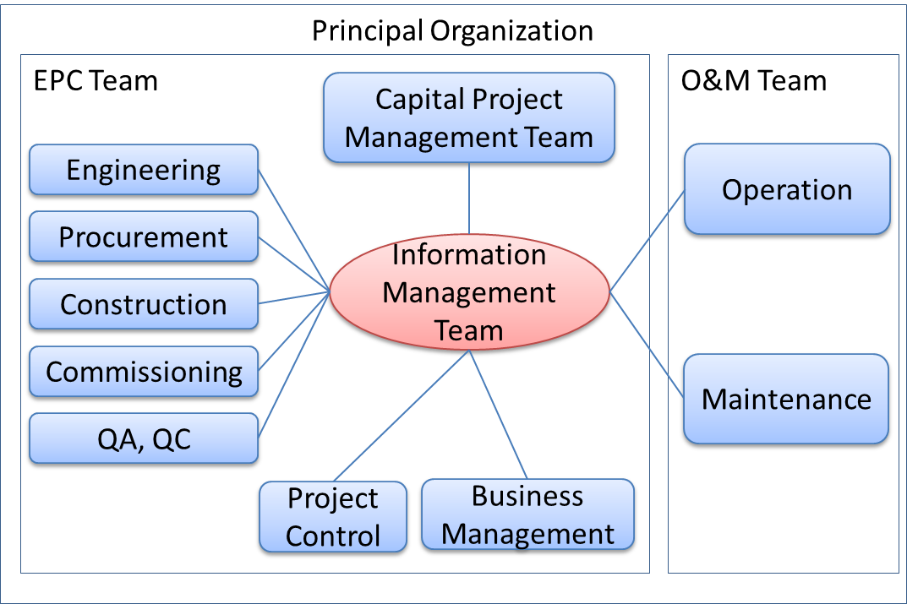
Figure 6: Principal Organization

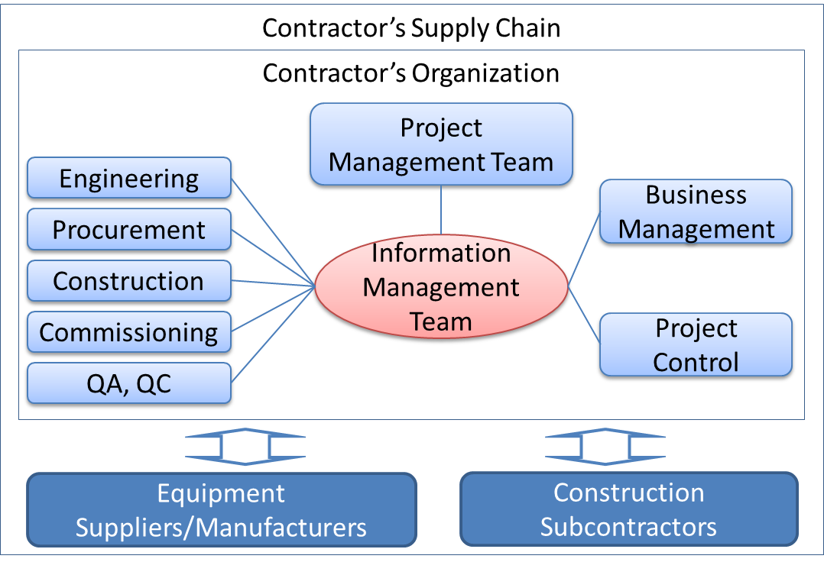
Figure 7: Contractor Organization

Information Interfaces among Stakeholders
In general, information flows within a company as well as outside companies. However, the official information flows among corporate stakeholders shall take place through the designated gateways of the companies. Principal, Contractor and other corporate stakeholders shall nominate, assign and delegate such gateway organization to officially exchange relevant information following the agreed procedures. The information provided by Information Supplier shall be coordinated and aligned before it is delivered to other parties.
Under the CFIHOS framework, though numerous communications happen among engineers, managers and other personnel of various companies, Information Managers officially represent their companies and the official information shall be exchanged through the agreed procedure.

Information Review and Approval Responsibilities
Information Supplier shall be accountable for their information quality. Information quality shall be managed at its source and Information Supplier shall not rely on Information Consumer’s reviews to comment and highlight issues. Information Supplier shall employ an internal information quality assurance process that ensures appropriate reviews are conducted by subject matter experts. Information Consumer may reject any information if such a process is not followed.

Information Consumer shall also review Information Supplier’s deliverables to ensure compliance with the Information Consumer’s technical requirements. Acceptance of information by Information Consumer does not relieve Information Supplier of responsibility for design accuracy or for compliance with applicable codes, standards or contractual requirements.

IM Organizations and Functions
Since CFIHOS handles data and documents, it is recommended that the IM organization has the integrated functions to manage data and documents.

In order to avoid the propagation of inconsistencies among data and documents, the IM organization shall gather, coordinate, consolidate data and documents before those are exchanged with external parties.

Principal’s IM Organization
The Principal’s IM organization shall be responsible for the requirements definitions, review and feedback comments to the Contractor’s deliverables, as well as coordination between its EPC team and O&M team so that Contractor receives consistent instructions.

Contractor’s IM Organizations
The Contractor’s IM Organization shall be solely responsible for receiving the IM requirements from Principal and for implementing IM solutions by coordinating various internal stakeholders such as engineering disciplines, procurement, construction and commissioning. The Contractor’s project team is responsible for enabling its IM organization to fulfil their obligations.

Suppliers/Manufacturers’ and Subcontractors’ IM Organizations
Contractor shall flow down IM requirements to its Suppliers/Manufacturers and Subcontractors (if required) and ensure they have IM functions in their organizations. The Suppliers/Manufacturers’ or Subcontractor’s IM teams may participate in the Principal/Contractor IM activities.

Joint IM Team
As soon as the project commences, the joint IM team should be formed between the Principal’s and the Contractor’s IM organization. This team shall be responsible for the following:
- Metadata Management, including but not limited to RDL and Data Models;
- Master Data Management;
- Master Tag Register Management;
- Master Document Register Management;
- Change Management;
- Monitoring and Reporting;
- Coordination among relevant stakeholders
- Identification of IM issues and solutions as well as escalation to upper project management;

IM Roles, Job Descriptions, Responsibilities, and Skill Sets

General
The IM roles, job descriptions, responsibilities and required skill sets are described in Annex C. The Contractor’s Information Manager and other personnel may be interviewed by the Principal’s Information Manager to evaluate their experiences and skill sets.

IM Roles

IM roles typically consist of the following:
- Information Management Lead (Information Manager);
- Document Control Lead;
- Data Management Lead;

Each of the above roles has its scope of work and responsibilities as well as required skill sets (see Annex C.1).

Data Owners and Data Stewards
Data Owners are those who produce data and ultimately responsible for the data quality in terms of accuracy, consistency, format conformity and completeness. Data Stewards are those who play the guardian role to verify and validate the data quality and report data quality issues to relevant parties. Both Data Owners and Data Stewards do not belong to the IM team but to organizations who produce and obtain the information.

- In the case of engineering, data owners are engineers who produce or approve specific Tags or Equipment data. Data Stewards are appointed by the disciplines to manage the data. The typical responsibilities of Data Stewards are:
- Understanding and managing the metadata defined in CFIHOS Specification Document [C-SP-001];
- Developing business rules, data quality rules, and data standards to ensure that disciplines follow those rules and standards;
- Managing and coordinating to resolve data quality issues;
- Executing operational data governance activities, and responsible for ensuring that day-to-day data governance policies and initiatives are adhered to;
- Monitoring, reporting and escalating issues to Data Governance organization;

Information Management Process and Activities

Information Management Process Overview
Between Principal and Contractor, the IM process starts at the pre-bidding phase and continues until the completion of the Contract as shown in Figure 8.

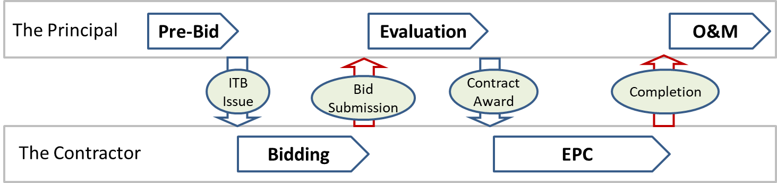
Figure 8: Project Phases
Table 3 shows typical actions taken at each phase.

Table 3: Actions in each phase
Phase | Action | Principal | EPC Contractor
Pre-Bid | Preparation of ITB to EPC Contractor using the CFIHOS Implementation Guide | O
Pre-Bid | Where Principal intends to novate an order or agreement to Contractor, preparation of ITB to Suppliers/Manufacturers using the CFIHOS Implementation Guide | O
Bidding | IM related technical clarifications and Answers | O | O
Upon Bid Submission | Express the degree of compliance with CFIHOS |  | O
Evaluation | Compare EPC Contractors bids on compliance with CFIHOS | O
Upon Contract Award | Issue a set of Reference Data Libraries | O
EPC | When Principal requests EPC Contractor to accept novated order or agreement, the consistency between the novated order or agreement and the contract with EPC Contractor should be confirmed. | O | O
EPC | Carry out the Kick-off meeting and regular meetings between Principal and EPC Contractor | O | O
EPC | Issue EPC Contractor's IM documents |  | O
EPC | Reviews and comments to the EPC Contractor's IM documents by Principal | O
EPC | Establish Data Governance procedure | O | O
EPC | Complete IT environment | O | O
EPC | Ensure Supplier/Manufacturer’s compliance with the CFIHOS requirements | O | O
EPC | Data gathering from Suppliers/Manufacturers |  | O
EPC | Information Handover at the frequency specified |  | O
EPC | Review, comment, approval or rejection of the information handed over | O
EPC | Prepare IT environment for Principal for operation and maintenance | O
Upon Completion | As-Built information handover |  | O
Upon Completion | Review, comment, approval or rejection of the As-Built information | O

Pre-Bidding Phase
Principal shall refer to CFIHOS Implementation Guide [C-GD-001] when producing the EPC Contract considering the following points.

Information handover requirements in the Contract
Since complete and accurate information is crucial for the safe and efficient operation of a plant, Principal shall issue a Contract Information Management Scope of Work and the information specifications to define the specific deliverables for a particular contract. Descriptions shall be unambiguous which information (data and documents) are to be delivered, and when and in which format it should be delivered. Principal shall also define details of the timing, frequency, and method for information hand over in a Contract Information Management Scope of Work.

IM related documents to be produced by Contractor
Principal may mandate the following documents to be submitted by Contractor at the bidding phase or EPC phase. The expected contents, level of details, and submission deadlines shall also be specified.
- IM Philosophy, Plan and Procedure;
- Data Management and Data Governance Plan and Procedure;
- IT Plan and Procedure;
- Document Management Plan and Procedure;
- Correspondence Management Plan and Procedure;
- Interface Management Plan and Procedure;
- Model Management Plan and Procedure;
- BIM Execution Plan and Procedures;
These documents shall show how Contractor plans to satisfy the CFIHOS requirements. Principal may also request Contractor to demonstrate the capabilities to achieve the desired results.

Consistency among the Contracts
Principal shall ensure the consistency among the CFIHOS related contract conditions for EPC Contractor and Suppliers/Manufacturers.

Bidding, Bid Submission, and Evaluation Phase

Clarifications and answers
To avoid misunderstanding and enforce clarities instead, Contractor may raise IM related clarifications to Principal. It is important that Principal and Contractor share the same understanding of the IM requirements.

IM related deviations and alternatives
Contractor may request deviations or submit alternative proposals for approval if they deem fit for the purpose by Principal. These proposals shall be submitted with reasons and details enough to prove that Contractor still satisfies the CFIHOS requirements.
Contractor shall state its compliance with, alternatives to, or deviations from the CFIHOS requirements at the bid submission.

On Contract Award

Adjustment of CFIHOS requirements
As a standard contracting practice, if deviations or alternatives are accepted by Principal, the Contract shall incorporate those agreed terms and shall be adjusted accordingly.

Project Dictionary and Classification
Principal shall formally issue Contractor a set of CFIHOS RDL [C-ST-001] at the commencement of the Contract including the following.
- Tag Classes and Properties Definitions;
- Equipment Classes and Properties Definitions;
- Document Classes Definitions;
- Model Classes and Model Definitions;

Contractor shall ensure all information delivered to Principal complies with the RDL. Where Contractor is unable to utilize the definitions and naming conventions in the RDL directly in its business processes and applications, Contractor shall map and convert their reference data to the Principal’s RDL so that the resulting information will still satisfy the RDL.

Application of the RDL by Contractor shall determine the Principal’s information requirements, for example:
- If a Tag is classified as a centrifugal pump, the reference data will identify which properties for that pump need to be delivered by Contractor. The property requirements are different if a different classification is used.
- If a Document is classified as a “Process Engineering Flow Scheme”, this class identifies that the final revision of the document shall be handed over at As-Built and whether a native file is required, and a translation or hardcopy is required.

Principal may revise the RDL during the execution of the works. Principal shall formally transmit any updates to Contractor, highlighting any changes. Contractor shall replace any earlier revisions of the reference data and ensure future compliance with the new revision.

If Contractor is unable to comply with any of the requirements resulting from the application of the Principal’s RDL, Contractor shall obtain written permission from Principal for any deviations.

Provision of Model Configuration Files
Principal shall formally issue Contractor a set of engineering tool configuration files like seed files, which shall be consistent with the RDL definitions.

EPC Phase

Kick-off Meeting and regular meetings
Achieving the CFIHOS goals requires joint efforts among Principal, EPC Contractor, Suppliers/ Manufacturers and/or Subcontractors. To facilitate the communication, EPC Contractor shall plan, request and conduct an immediate a kick-off meeting with Principal with the following agendas:
- Explanation and confirmation of the CFIHOS requirements by Principal;
- Confirmation of schedules and milestones by both parties;
- Confirmation of communication methods between parties;
- IM organization and assignments of roles;
- Detail clarifications and answers by both parties;
- Plan for IM regular meetings;

Submission of Contractor’s IM related documents
EPC Contractor shall submit specified IM related documents to Principal for review and approval according to the designated milestones. EPC Contractor shall hold workshops with Principal to explain the intention and implementation plans as written in those documents and to receive feedback from Principal.

Data Management and Data Governance Activities
As soon as Principal and EPC Contractor establish IM organization and roles, data management and data governance activities should commence according to the agreed plans and procedures. The following should be focused as priorities for those activities.
- Data management activities to satisfy the information quality indicated in CIS;
- Document management programs and workflows;
- Establishing the project data governance team;
- Assigning the data stewards representing various disciplines who are responsible for the data, information and documents the disciplines produce;
- Tags and equipment data management activities:
  - Tracking estimated number of tags and pieces of equipment;
  - Tracking the progress of tag and equipment data gathering;
- Validation and consistency check results for:
- Tags and equipment data;
- Tag to tag relations;
- Document to tag, tag to document relations;
- Document to document relations;

EPC Contractor is ultimately responsible for data gathering through the Information Supply Chain including the data provided by its suppliers/Manufacturers. However, EPC Contractor and Principal should conduct the joint effort to expedite the data gathering from the Information Supply Chain.

On Contract Completion
Contractor shall submit all the As-Built Information/Data to Principal accurately reflecting the Tags and physical Equipment built into the facility, within the specified period after the physical facility handover, by incorporating the As-Built information into documents and drawings and the final MDR and MTR.

During Operation and Maintenance
The Data and Documents shall be kept updated when any changes occur during the operation and maintenance period by Principal. Lessons Learnt and continuous improvements shall be incorporated for the subsequent projects.

Decommissioning of Plant
Principal may decide what to do with the data and documents when the plant is de-commissioned.

Bibliography
- ISO 19005-1:2005 Document management - Electronic document file format for long-term preservation
- ISO/IEC 27001, 27002 Information security management systems
- ISO 8000 Data Quality
- ISO 9000 Quality management
- BS1192 and PAS1192, Building Information Modelling
- DAMA International (2017), Data Management Body Of Knowledge 2nd Edition

Annex A: Building Information Modelling

  - General
Refer to BS1192 and PAS1192 (British Standards and Publicly Available Specifications from BSI) for additional information on the BIM concept and Figures relating to Information Hand Over including the related management processes, and nature and types of information. The process starts with the Employer’s Information Requirements (Principal’s Information Requirements in CFIHOS) and leads to the BIM Execution Plan and Master Information Delivery Plan. The BIM concept differentiates plant related information into two categories, one is a Project Information Model, and the other is an Asset Information Model.

  - Project Information Model - Work in Progress
Project Information Model is the documents, non-graphical data, and graphical data which are still work in progress and subject to change. Therefore, they are not used for the Principal’s operation and maintenance.

  - Asset Information Model – Archives
Asset Information Model, on this other hand, are As-built information at the time of the physical plant handover, which are used for operation and maintenance.
Principal or Contract may elect to demand Project Information Model to be included in the Information Handover plan.

  - Common Data Environment (CDE)
The Common Data Environment is a concept to share, review, publish, and maintain the data and documents. CDE is meant to achieve the ‘Single Source of Truth’ principle, though it may be built physically by using multiple IT environments such as electric document management and multiple databases.
CDE manages Project Information Model and Asset Information Model where different stakeholders may be interested in either model.

Annex B: Transmittal

  - General
All the CFIHOS related documents shall be delivered with transmittals through EDMS. This annex shows typical examples of how it is organized. How a transmittal should be organized and transmitted for a Project shall be specified in the Contract by Principal.

  - Components in a Transmittal
A transmittal may contain the following components. Those components do not necessarily represent physical files if a certain EDMS is used.
The Transmittal: contains the metadata of the Primary File, the Native Files, the Additional Files and the Index File and may be created automatically by EDMS or created manually in a separate file as a cover page.
Primary File: is a file registered in Master Document Register submitted, usually in a single PDF file.
Native Files: are used to build the Primary File. A single PDF file can be produced by multiple native files such as MS Word and MS Excel files converted to form the PDF.
Reference Files: are any additional files to supplement the submission;
Index File: contains an index showing which files are attached to the submission;
Zip File: packages other files;
  - Transmittal and Transmission Options

    - Transmittal Options
Table B.1 shows various transmittal options that can be adopted by Principal. The combinations of those options will form the requirements of document submissions. Please note some of options may be dependent on other options.

Table 4: Transmittal Options
Options | Choice | Description
Zip Option | Allow Zip | Zip file(s) can be used in document submissions.
 | Prohibit Zip | Zip files not allowed in document submissions.
Password Option | Allow Password Protection | Documents can be or shall be protected by passwords. In this case, Principal specifies password properties (eg strength) and how the password is transmitted.
 | Prohibit Password Protection | Documents shall not be protected by passwords.
Single or Multiple File Option | Single File | Only one file is allowed in a single document submission where multiple files can be combined in one zip file if the zip is allowed.
 | Multiple Files | Multiple files can be contained in a single document submission
Transmittal Creation Option | Manual Transmittal | When EDMS does not create a transmittal, it shall be created manually and shall contain all the required information as a cover page.
 | EDMS Transmittal | When EDMS creates a transmittal such as Aconex, the form and the document metadata of the transmittal should be defined for the document submission.
Index File Option | Separate Index File | Index of files should be created as a separate file
 | Index Information | Index information can be described as a table in the Transmittal itself or in the cover page.

    - Transmission Method Options
The mechanism for transferring the Transmittals between Principal and Contractor shall be agreed at the commencement of the contract period. The following table shows various transmission options that can be adopted by Principal.

Shared EDMS:
Principal may instruct Contractor to directly access the Principal’s EDMS. In such a case, documents are submitted using the EDMS application. Principal shall specify the following elements:
- Authentication: User ID and password to access the EDMS;
- Permission: Which roles are provided and what actions are allowed for the roles;
- System Information: Specific requirements such as browser types and versions and system constraints;
- Manuals and Training: Principal may provide the user manual, training or workshops for Contractor to become familiarized.
- Workflow Specifications: Types of workflows to be used for Contractor;

FTP and Shared Folders;
FTP Site
Upon contract award, Principal and Contractor establish shared folders allowing each other to access. The following elements shall be specified.
- Protocol: Port and the types of FTP shall be specified (Which port used for which protocol is allowed such as basic FTP with Port 21, SFTP or FTPS.
- Authentication: User ID and password to access the shared folder;
- Permission: Which folders can be accessed with which permission such as download, upload, edit, move or delete.
- Maximum File Size and Total Capacity: The maximum size of files for upload and what to do when the total folder capacity is reached.

Notification
When a transmittal is uploaded to the shared folder, the sender shall notify the receiver by sending an E-mail containing a clear reference to the Transmittal number and its location in the shared folder.

HTTP and Shared Folders:
This option is the same as above FTP except that a different port and protocol is used such as HTTP or HTTPS.

Web API (Application Programming Interface):
Principal may allow Contractor to use the Web Api provided by Principal, in which case the following elements shall be specified:
- Authentications and Permissions: see above in FTP
- Web Api specifications: Url, parameters, and other HTTP specifications such as HTTP methods (GET, POST, PUT, PATCH, DELETE), header, authorization and body

  - Examples
    - Combinations of Transmission Options
Two examples are presented to show how the options can be applied (see Table B.2).

Table 5: Transmission Options
Options | Example 1 | Example 2
Zip | Use Zip | No Zip allowed
Password | No password allowed | No password allowed
Multiple File | Multiple Files in Single Zip File | Multiple Files allowed
Transmittal Creation | Manual Transmittal | EDMS Transmittal
Index | Separate Index File | Index in the Transmittal
Transmission | FTP Upload/download | Shared EDMS

    - Example 1
In this example, a transmittal carries only one file in the Zip format containing Cover Page, Index File, Primary File, Native Files and Reference Files (see Figure B.1).
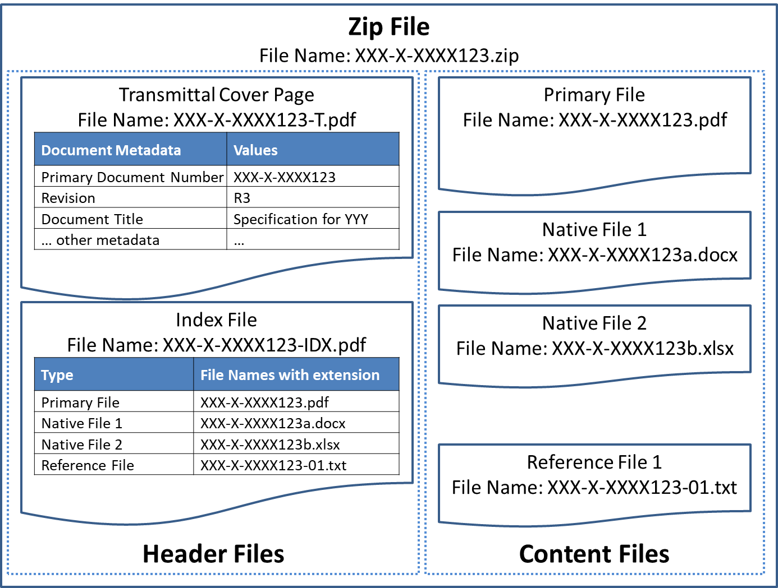
Figure 9: Zip File Case

    - Example 2
In this example transmittals are created using an EDMS, where document metadata are stored in the system. The transmittal can contain textual description and index in a table format together with attachments containing Primary File, Native Files and Reference Files (see Figure B.2).
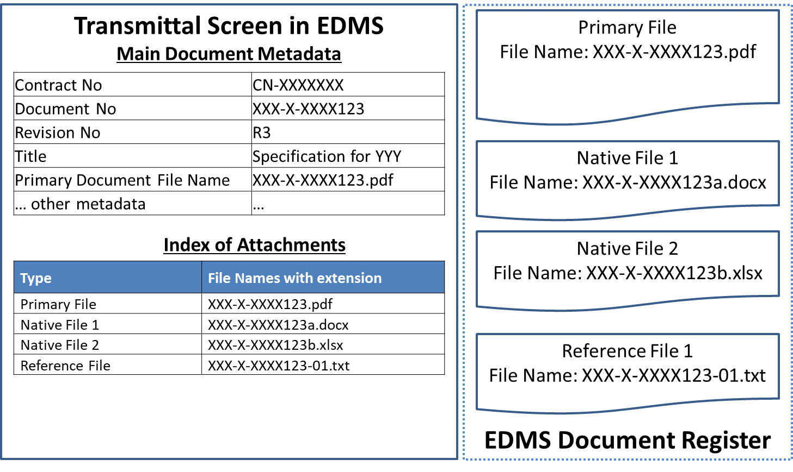
Figure 10: EDMS Case

Annex C: IM Job Description

  - Information Management Roles and Job Description

Information Management is typically conducted by an IM team consisting of various IM roles. Each role in the IM team of Principal shall have its corresponding role of Contractor. Major IM roles are:

- Information Management Lead (Information Manager);
- Document Control Lead;
- Data Control Lead;

All the above roles focus on consistent application of Information Management processes relating to the delivery of project scopes. The functions, tasks, responsibilities, and skill sets that are common to all the IM roles are:

- Collaboration between Principal and Contractor to ensure that the requirements for overall IM processes are understood and adhered to;
- Demonstrated leadership skills and collaboration with other leadership positions;
- Fair understanding of EPC business processes;
- Demonstrated familiarity with IM tools and systems typically Electronic Document Management System, Collaboration Systems, and Data Validation tools;
- Proficient in IM software applications;

The sections below describe functions, tasks, responsibilities and skill sets expected for each IM role.

  - Information Management Lead

    - Main Functions
Information Management Lead in any parities shall be familiar with Information Management best practices and industrial standards.

The Principal’s Information Management Lead shall:

- Collaborate with the Principal’s Production organization to ensure Operations needs are met, resources are well integrated into routing and approval processes, and stewarding Handover process between Project Team and Operations;
- Communicate IM key performance indicators and issues to project team, central support organization(s) and local operations organization;
- Responsible for information hand over to Operations;
- Liaise continually with Operations Management to ensure effective integration and support;

The Contractor’s Information Management Lead shall:

- Collaborate with the Principal’s Information Management Lead to ensure the requirements are met, resources are well integrated into routing and approval processes, and stewarding Handover process between Principal and Contractor;
- Communicate IM key performance indicators and issues with the project team;

    - Tasks and Responsibilities
Responsibilities of the Contractor’s Information Management Lead may include any or all of the following, depending on the specific needs of the assignment:

- Be familiar with all Contract Scopes of Work and all the Project IM requirements;
- Have ultimate responsibility for IM planning and management of documents, data, and models;
- Develop and maintain the Project IM Strategy and Plan ensuring compliance with the Project IM requirements;
- Stay abreast of application of IM processes within the EPC(s) and promote consistency;
- Effectively execute IM Plans, Document Numbering Schemes, Distribution Matrix, and supporting procedures;
- Develop the Information Handover Plan to facilitate the transfer of relevant information from Contractor to Principal;

    - Required Skill Sets and Experience for the Contractor’s Information Management Lead
- Understanding of the importance of data, information, and document assets;
- Experience in major EPC projects as Information Management Roles;
- Familiarity with data models, metadata, data quality, information security, document management and data governance based on the standards that Principal specifies;

  - Document Control Lead

    - Main Functions
The Principal’s Document Control Lead shall:
- Collaborate with Contractor to ensure requirements for overall Information Management processes are understood and adhered to;
- Collaborate with the Production organization to ensure Operations needs are met, resources are well integrated into routing and approval processes, and stewarding Handover process between Project Team and Operations;

    - Tasks and Responsibilities
Responsibilities of a Document Control Lead may include any or all of the following, depending on the specific needs of the assignment:
- Be familiar with and execute in compliance with the Project Document Management Strategy, IM Plan, and relevant requirements;
- Develop and implement supporting procedures governing the document control processes, including but not limited to document control procedure;
- Execute and provide the status of project tracking and archiving of deliverables throughout the project lifecycle (recording revisions, revision purposes, distribution and transmittal histories) in accordance of project requirements;
- Support the development of IM key performance indicators and issues;
- Prepare and issue periodic reports describing status and issues for document management;
- Manage all paper and electronic document flows within the project, and from/to Contractors or Suppliers/Manufacturers;
- Maintain the various functionalities of EDMS, such as workflows, transmittals, uploading, and downloading electronic files, searching functions;
- Provide on-boarding training for project team members relating to Document Control;
- Supervise a team of project document controllers and/or manage document control services rendered by a third-party provider;
- Ensure all applicable metadata fields are accurately updated and maintained in applicable Document Register(s);
    - Required Skill Sets and Experience for the Contractor’s Document Control Lead
- Experience with deliverables management (revision control, registers, libraries, etc.);
- Experience issuing and managing technical transmittals and correspondence;
- Familiar with cross-discipline engineering documents (requirements and use) and typical discipline routing and approval processes;
- Demonstrated familiarity with EDMS and document/data workflow management;

If Principal specifies a particular EDMS to be used by Contractor, training, demonstration, workflow setup (routing, role, permission) before EPC should be provided by Principal’s Document Control Lead.

  - Data Control Lead

    - Main Functions
The Data Control Lead focuses on then consistent application of IM processes relating to the data delivery of the project scopes.

The Principal’s Data Control Lead is characterized by:
- Collaboration with the Contractor’s Data Control Lead to ensure that requirements for overall IM processes are understood and adhered to;
- Collaboration with the Production organization to ensure Operations needs are met, resources are well integrated into routing and approval processes, and stewarding Handover process between Project Team and Operations;

The Contractor’s Data Control Lead is characterized by:
- Collaboration with the Principal’s Data Control Lead to confirm that requirements for overall IM processes are understood and adhered to;
- Collaboration with the Contractor’s internal organizations to ensure CFIHOS requirements are satisfied, resources are well integrated and stewarding Handover process to Principal;

    - Tasks and Responsibilities of the Contractor’s Data Control Lead
Responsibilities of the Data Control Lead may include any or all of the following, depending on the specific needs of the assignment:
- Be familiar with and execute in compliance with the Project Data Management Strategy, IM Plan, and relevant Project Design Specifications (PDSs);
- Develop and implement supporting procedures governing the data control processes, including but not limited to the data control procedure;
- Support Contractor and Supplier/Manufacturers configurations of data management tools to support the effective delivery of data through the project lifecycle;
- Execute and provide the status of project tracking and archiving of deliverables throughout the project lifecycle (recording revisions, revision purposes, distribution and transmittal histories) in accordance with project requirements;
- Support development of Information Management key performance indicators and issues;
- Prepare and issue periodic reports describing status and issues for data management;
- Collaborate effectively with the document management resources in the Information Management team;
- Manage collection, integration, and validation of data from various data sources;
- Manage all data flow within the project, and from/to vendors or subcontractors;
- Maintain the Data Management System(s);
- Maintain the project reference data libraries for data-centric applications - ensuring maximum alignment to specified data structures and reference data library;
- Provide on-boarding training for project team members relating to Data Control;
- Supervise a team of project data controllers and/or manage data control services rendered by a third-party provider;
- Ensure all the relevant metadata fields are accurately updated and maintained in applicable Asset Register(s);

    - Required Skill Sets and Experience for the Contractor’s Data Control Lead
- Understanding of the importance of data and information assets;
- Experience in major EPC projects as data management roles;
- Familiarity with data models, metadata, data quality, information security, document management and data governance;
- Familiarity with data integration tools, data validation tools and Web API implementation;

Annex D: Figures and Tables Lists

Figure List
Figure 1: CFIHOS Document Structure 9
Figure 2: Information Life Cycle with Information Supplier and Information Consumer 14
Figure 3: Information Supply Chain 16
Figure 4: Typical Data/Information Governance Organization 28
Figure 5: Project Stakeholders 29
Figure 6: Principal Organization 30
Figure 7: Contractor Organization 30
Figure 8: Project Phases 32
Figure 9: Zip File Case 40
Figure 10: EDMS Case 41

Table List
Table 1: Maturity of Information and CFIHOS 12
Table 2: Information Life Cycle Process 14
Table 3: Actions in each phase 33
Table 4: Transmittal Options 38
Table 5: Transmission Options 39

