CFIHOS – Specification Document

Acknowledgements

In 2012, Shell approached Netherlands-based process industry organization USPI to explore turning their corporate information standard into an industry-wide standard. The result was the CFIHOS (Capital Facilities Information Handover Specification) project.

Its aim is to offer practical, standardized specifications for information handover that work across the supply chain – operators, contractors and suppliers. The most recent CFIHOS industry standard (Version 1.4) was published in October 2019 by USPI with support from the Engineering Advancement Association of Japan (ENAA). This document, describing the scope and procedures of CFIHOS, is part of this standard.

Following a member vote in 2019, the future governance, development, and maintenance of the CFIHOS project and standard moved from USPI to IOGP in January 2020, becoming Joint Industry Project (JIP)36.

**Disclaimer**

Whilst every effort has been made to ensure the accuracy of the information  
contained in this publication, neither IOGP nor any of its Members past present or  
future warrants its accuracy or will, regardless of its or their negligence, assume  
liability for any foreseeable or unforeseeable use made thereof, which liability is  
hereby excluded. Consequently, such use is at the recipient’s own risk on the basis  
that any use by the recipient constitutes agreement to the terms of this disclaimer.  
The recipient is obliged to inform any subsequent recipient of such terms.

This publication is made available for information purposes and solely for the private  
use of the user. IOGP will not directly or indirectly endorse, approve or accredit the  
content of any course, event or otherwise where this publication will be reproduced.

**Copyright notice**

The contents of these pages are © International Association of Oil & Gas Producers.  
Permission is given to reproduce this report in whole or in part provided (i)   
that the copyright of IOGP and (ii) the sources are acknowledged. All other rights are  
reserved. Any other use requires the prior written permission of IOGP.

These Terms and Conditions shall be governed by and construed in accordance  
with the laws of England and Wales. Disputes arising here from shall be exclusively  
subject to the jurisdiction of the courts of England and Wales.

CFIHOS – Specification Document

|  |  |  |
| --- | --- | --- |
| Version | Date | Comments/History |
| 1.4 | April 2020 | IOGP republication of CFIHOS document first published in October 2019. |

# Foreword

The Capital Facilities Information Handover Specification (CFIHOS) is an industry standard developed to improve how information is exchanged between the companies who own, operate, and construct equipment for the process and energy sectors. Starting with a common equipment naming taxonomy and supporting specifications, its goal is to become a common language for the exchange of information in these sectors.

The initial focus is on information, both structured data and traditional document formats, which must be handed over when a project moves from its development to operations phase. Ultimately, the aim is for CFIHOS to become the de-facto standard for information exchange throughout the physical asset lifecycle, from vendor information through to decommissioning.

The Reference Data Library or “RDL” lies at CFIHOS’ heart. This library gives a standard and unified naming convention for equipment, its attributes, disciplines, and documents. Version 1.4 of the CFIHOS RDL includes:

* A list of classes for Tag and Equipment (what the equipment does and what it is)
* A list of properties (attributes, measures, characteristics etc.)
* Lists of requirements by class (data and document requirements)
* Standard unique coding of data to facilitate digital design and other workflows
* A list of document types
* A list of disciplines

At present, CFIHOS covers only the exchange of structured data and documents - not graphical, geometry, and model data. In the future, CFIHOS could be extended to include graphical and design tool and support spare parts procurement, inspection, test requirements, commissioning check sheets, Work Packaging, configuration management, and even drive payment.

CFIHOS is being developed collaboratively by project members as a practical standard to ensure the systematic and reliable exchange of information between all participants involved in the information supply chain, thereby reducing cycle times and costs. More than 70 organizations contributed to the development of CFIHOS Standard version 1.4, which is supported by several leading software industry design tools.

Contents

Foreword 4

Introduction 6

1 Scope 6

2 Normative References 7

3 Terms, Definitions, Acronyms and Abbreviations 7

4 Applicable Standards and Documents 9

4.1 International Standards 9

4.2 CFIHOS Reference Data Library (RDL) 9

5 Data 10

5.1 Tag and Data Management 10

5.2 Data Specification 11

5.2.1 Handover Plant Breakdown Structure 11

5.2.2 Classification 11

6 Documents 11

6.1 General 11

6.2 Document Specification 11

6.2.1 Document Numbering 11

6.2.2 Discipline 12

6.2.3 Document Type Classification 12

6.2.4 Discipline Document Type Classification 12

6.3 Document Properties (Metadata) 12

6.4 Document and File Structures 13

6.4.1 Books (or binders) of Documents 13

6.4.2 File Requirements 13

6.4.3 Additional Files 14

6.4.4 Files to be delivered 15

6.4.5 Image Quality 15

6.4.6 Hyperlinks 15

6.4.7 Different Languages 15

6.4.8 Character Set 16

6.4.9 Document Size 16

6.5 Document References 16

6.6 Physical Record Requirements 16

7 Bibliography 17

**Annex A -Information Specification** 18

A.1 General 18

A.2 Data model 18

A.3 Data Dictionary 21

A.4 CFIHOS Reference Data Library 22

# Introduction

This document defines an information handover specification for capital facilities between Principals, Contractors and Suppliers/Manufacturers. It specifies the engineering information Principals require for future operations and maintenance of the facilities.

This specification is based on a set of general principles and requirements such that:

* Information handover should be related to the physical assets that together form the facility.
* It serves as a common nomenclature for efficient communication between the involved stakeholders in the supply chain.

CFIHOS Implementation Guide for Principal [C-GD-001] and CFIHOS Implementation Guide for Contractor [C-GD-002] provide detailed guides on how to use this specification.

# Scope

This specification covers:

* Handover of information for production facilities
* Handover along the process industry plant engineering supply chain that consists of Principals, Contractors, and Suppliers/Manufacturers.

Where:

* + The Principal is the end client company that owns the production facility and is responsible for operation and maintenance.
  + The Contractor is responsible for design, detailed engineering, procurement, construction and commissioning of a facility.
  + The Maintenance Contractor maintains and/or operates the facility.
  + The Supplier/Manufacturer delivers the equipment used to construct a facility and is responsible for the design, manufacturing and assembly of a particular piece of equipment.
* That part of engineering information created by a Contractor and Supplier/Manufacturer required by the Principal to operate and maintain a facility and to support future design changes.

Out of scope for this specification:

* All engineering information created by a Contractor and Supplier/Manufacturer that will not be required by a Principal to operate and maintain a facility or for any future design changes.
* The processes that govern how a Contractor or Supplier/Manufacturer creates the engineering information.
* The systems used to develop the information nor the systems in which the information will be stored at handover

**Purpose and Objectives**

Create a common specification for Principals, Contractors and Suppliers/Manufacturers for the handover of engineering information in a facilities project, such that:

1. This specification is an integral part of the full set of specifications which specifies:
   1. The physical plant
   2. The information required
2. The information required is exactly what is needed to satisfy:
   1. Any information requirements from statutory authorities
   2. Approval and acceptance of delivery by the involved stakeholders
   3. The design for future changes to the plant
   4. The Operation & Maintenance during the lifetime of the plant
3. The specification can be applied across the supply chain

# Normative References

1. CFIHOS Scope and Procedure [C-TP-001]
2. CFIHOS Implementation Guide for Principal [C-GD-001]
3. CFIHOS Implementation Guide for Contractor [C-GD-002]
4. CFIHOS Reference Data Library (RDL) [C-ST-001]
5. CFIHOS Data Dictionary [C-DM-002]
6. CFIHOS Knowledge Guide [C-GD-003]

# Terms, Definitions, Acronyms and Abbreviations

**Additional Files:** A logical collection of physical computer files that are associated to **one** document revision identification.

**Application**: an application is a computer program designed to help people perform an activity.

**Approved For Construction**: This is a formal milestone indicating the start of construction/erection

activities.

**As-Built:** The As-Built documentation and data associated with the facility, system or component represents the actual physical “as is” situation.

**Contract Information Management Scope of Work (sometimes written IM SOW)**: In this contractual document the Principal specifies the terms and conditions for information delivery by the Contractor. Where it is applicable and feasible, quality benchmarks and criteria to fulfil may be included. For any details that could be either referred to specific specification documents or included in the scope of work.

The **Contractor** is the party that carries out all or part of the design, engineering, procurement, construction, commissioning or management of a project or operation of a facility.

**Controlled Document:** A controlled document is any digital or hard-copy entity which is required by a company, a standards organization, or a regulatory agency to be managed within a tightly controlled process that maintains the integrity of its content through revisions.

**Discipline Document Type**: An association between Disciplines and Document Class names. In the CFIHOS context, the term Discipline Document Type is a unique identifier for types of documents. This term has been developed to cater for situations where a document class is common to more than one discipline, for example, a process engineering flow scheme should only be produced by the process discipline, whereas a data sheet could be produced by many disciplines depending on the equipment where each discipline is responsible for part of the content.

**Electronic Document Management System:** An electronic document management system is a computer system (or set of computer programs) used to track and store electronic documents.

**Export Control Classification Number (ECCN):** An Export Control Classification Number (ECCN) is a specific alphanumeric code that identifies the level of export control for articles, technology and software (collectively, "Items") that are exported from member states of the Wassenaar Arrangement on Export Controls for Conventional Arms and Dual-Use Goods and Technologies, including the United States. The ECCN classification that applies to any specific item is determined by referring to a table such as that issued for the United States by the Bureau of Industry and Security and for Europe by Regulation 428/2009.

**Handover of Information:** The formal process between Principal and Contractor for transfer of ownership and responsibility for the change management of information aligned with the official acceptance of a physical facility.

**Handover Plant Breakdown Structure**: The plant breakdown structure that structures the handover deliverables in relation to the physical assets.

**Information Handover Specification (IHS):** The resulting document when this industry template is applied for a particular project describing the explicit set of requirements to be fulfilled. Linked to this document is a Reference Data Library that describes the data characteristics and document types.

The **Maintenance Contractor** maintains the plant on behalf of the Principal.

**Original Equipment Manufacturer** (OEM) is the company that originally manufactured the equipment item and from which the equipment vendor purchased the equipment ultimately for the Principal’s use.

The **Principal** is the party that initiates the project and ultimately pays for it. This includes any agent or consultant authorised to act for, and on behalf of, the Principal.

**Reference Data Library (RDL):** The project dictionary that defines in detail the tag and equipment classes and their properties required for the electronic handover of information. The RDL also includes the CFIHOS Unique ID codes.

The **Supplier/Manufacturer** is the party that manufactures or supplies equipment and services to perform the duties specified by the Contractor.

**Tag Register:** The complete list of items in a plant which the Principal would like to trace i.e. have documentation available, during the lifetime of an industrial plant. Note that this list is restricted to those items that are required to perform the business operations of the Principal. Note that:

* The word **shall** is used to indicate that a provision is mandatory.
* The word **should** is used to indicate that a provision is not mandatory, but recommended as good practice.

# Applicable Standards and Documents

This section describes the applicable standards and practices relevant to this document in specifying what information is handed over to the Principal.

## International Standards

The international standards relevant to this area of work include ISO 10303, ISO 14224 and ISO 15926:

* ISO 10303 is a standard for the computer-interpretable representation and exchange of industrial product data. The objective is to provide a mechanism capable of describing product data throughout the life cycle of a product, independent from any particular system. Its official title is “Industrial automation systems and integration - Product data representation and exchange”, also known as STEP or the “Standard for the Exchange of Product model data”.

* ISO 14224 is titled “Petroleum, petrochemical and natural gas industries -- Collection and exchange of reliability and maintenance data for equipment”. It provides a comprehensive basis for the collection of Reliability and Maintenance (RM) data in a standard format for equipment in all facilities and operations within the petroleum, natural gas and petrochemical industries during the operational life cycle of equipment.
* ISO 15926 is titled: "Industrial automation systems and integration—Integration of life-cycle data for process plants including oil and gas production facilities". It specifies a conceptual data model for computer representation of technical information about process plants.

## CFIHOS Reference Data Library (RDL)

The RDL is a “dictionary” giving a standard and unified naming convention for equipment, its properties, disciplines and documents. It is a set of information requirement specifications for documents and tagged items. The CFIHOS RDL contains the following:

* A list of classes for Tag and Equipment (what the equipment does and what it is)
* Lists of requirements by class (data and applicable document references)
* A list of properties (attributes, measures, characteristics etc.)
* A list of disciplines
* A list of document types

Contractor shall deliver tag data and applicable document references in accordance with the CFIHOS RDL [C-SP-001] and other Principal specific documents including but not limited to engineering tagging specification and document numbering specification.

By application of the CFIHOS RDL, Contractor is able to determine Principal’s information requirements, for example:

* If a Tag is classified as a temperature transmitter, the CFIHOS RDL defines which properties for that temperature transmitter need to be delivered by the Contractor. The property requirements would be different if a different classification is used.
* If a Document is classified as a Piping and Instrumentation Diagram, the CFIHOS RDL will identify the final revision of the document to be handed over at As-Built; if a native file is required and whether a translation or hardcopy is required.

# Data

## Tag and Data Management

A facility’s information is concerned with the functional definition of the facility (its operating parameters), and how the facility then fulfils the functional requirements i.e. the physical definition of the facility.

**Tag (functional) data properties** are generally the technical design requirements for the item, for example the ‘Maximum Design Pressure’ of a pump. Functional data is normally available when the design engineer has developed the datasheet for the equipment.

**Equipment (physical) data properties** normally pertain to the characteristics of the device used to fulfil the design requirements, for example the type, the weight and the dimensions of a pump. Physical data is normally delivered to Contractor by the supplier or original equipment manufacturer (OEM).

The full tag dataset that shall be handed over by Contractor to Principal is the combination of Tag and Equipment data.

The contractor shall deliver the tag class and equipment class represented by each tagged item as part of handover. Furthermore, each class of tagged item has a definite list of tag and equipment data properties that shall be provided to the Principal. All this is defined in the CFIHOS RDL. Contractor shall:

* Ensure all tag numbers on Contractor, supplier and sub-contractor documents and drawings conform to the Principal’s tagging specification.
* Deliver tag data according to the requirements detailed in the CFIHOS RDL.
* Deliver tag data to Principal in a structured electronic format.
* Submit to Principal intermediate and final handover Tag Data at Principal’s request.
* Ensure all tag numbers are separately identified in the master tag register.
* Ensure the format of engineering units of measure used for tag data is consistent with the CFIHOS RDL.
* Ensure all data delivered is consistent with the corresponding information that appears in the latest approved revisions of issued documents including manuals and dossiers.
* Be responsible for the quality (completeness, correctness and consistency) of Tag Data delivered by Contractor and Contractor’s suppliers and sub-contractors.
* Maintain throughout project execution the Tag-to-Tag relationships electronically in accordance with the CFIHOS RDL. Examples of Tag-to-Tag relationships include (but are not limited to):
* Parent-child associations (e.g. equipment item on a skid)
* From/To connectivity (e.g. cables, piping lines)
* System and Completion subsystem membership
* Piping line number connectivity (e.g. valves)
* Loop ID
* Maintain throughout project execution the Tag-to–Document Number cross-references in accordance with the CFIHOS RDL. Document numbers that are cross-referenced to tags shall be validated by Contractor against the Master Document Register (MDR).
* Ensure that Original Equipment Manufacturer (OEM), model, and serial number are delivered to Principal where manufacturer, model number and serial number are specified as a requirement in the CFIHOS RDL.
* Provide to Principal spares data in accordance with Principal’s spares tool.
* Hand over complete “As-Built” tag data in accordance with the CFIHOS RDL for the entire scope (including supplier/manufacturer tagged items).

## Data Specification

The Principal’s data requirements are split into two sections:

* Handover Plant Breakdown Structure (see also Annex A.2)
* Classification (see also Annex A.3 “3. Overview of the Classification and Properties of A.2.2 High-level view of the CFIHOS data model”)

### Handover Plant Breakdown Structure

A Plant Breakdown Structure provides an exhaustive, hierarchical tree structure of deliverables that make up the plant, arranged in a relationship. The structure takes into account physical aspects (how is it constructed), functional aspects (what does it) and location aspects (where is it located). Annex A.2 defines the Plant Breakdown Structure used in the Handover process recognised as such by the Principal for data handover.

### Classification

Classification is used to define any functional and physical data properties requirements. Figure 3 in Annex A 2.2 “3. Overview of the Classification and Properties of A.2.2 High-level view of the CFIHOS data model”, defines how the Principal for data handover recognises the classes and their properties.

A list of "classes" and their property requirements are defined in the CFIHOS RDL as provided by the Principal.

This document provides specification to identify the relevant scope for the Contractor in relation to classification. Principal shall communicate any additional requirements or deviations from this document.

# Documents

## General

The requirements for document handover are as specified in this document, the accompanied CFIHOS RDL, and other company-specific requirements. Contractor shall ensure that these requirements are applied to all documents created as part of its scope, including those originated by the subcontractors and Suppliers/Manufacturers. Contractor shall:

* Ensure all documents are submitted to Principal in accordance with the process described in the CFIHOS Scope and Procedure [C-TP-001] or as may be further instructed by Principal.
* Ensure document titles, numbers and revisions are identical on the document and the MDR.
* Ensure that documents are complete with appendices and attachments.
* Ensure that document cross references are current, correct and consistent.

## Document Specification

Contractor shall deliver all documents to Principal in accordance with the CFIHOS RDL which provides a specification for Principal’s requirements on Discipline Document Type basis. Contractor shall treat all deliverables to be handed over to Principal as controlled documents and the following shall apply.

### Document Numbering

Contractor shall ensure all documents issued by contractor, sub-contractors and Suppliers/Manufacturers are numbered in accordance with the Principal’s Document Numbering Specification. This document number shall be used consistently in the document content (electronic and hardcopy) and the metadata supplied for the document.

Contractor shall produce a new revision whenever an update of a document is issued to Principal. A new revision is raised in case information regarding form, fit, function or performance of a component or system is changed; any textual editorial changes will be collected until a new revision will be issued.

Revision code shall be in accordance with Principal’s Document Numbering Specification.

### Discipline

Discipline refers to a branch of knowledge of expertise which is responsible for the content of a deliverable. A unique identifier for Discipline shall be used to classify documents as per the CFIHOS Data Dictionary.

### Document Type Classification

A unique identifier for Document Classification shall be used to classify documents as per the CFIHOS Data Dictionary.

### Discipline Document Type Classification

Discipline Document Type Classification is an identification of the type of document required for the discipline, and their related delivery requirements. A unique identifier for types of documents to cater for situations where a document is common to more than one discipline, shall be used to classify documents as per the CFIHOS Data Dictionary.

Contractor shall ensure all documents handed over to the Principal are assigned an appropriate discipline document type code and that all handover requirements of the relevant discipline document type code are satisfied in accordance with the CFIHOS RDL.

Contractor shall not create documents containing the content of multiple discipline document types (especially if the content may be updated independently) but split such documents into individual documents per discipline document type. If necessary, these may be formed into a book, as described in section 6.4.1 below.

Contractor shall not create new discipline document type combinations without prior approval from Principal.

## Document Properties (Metadata)

Each document submitted by Contractor to Principal shall be delivered along with the following metadata as structured data in accordance with the following Data Dictionary Tables:

* DOCUMENT MASTER - A Document Master is a placeholder that allows a project to identify a particular information content to be created or updated.  A Document Master is identified by a document number, and it groups all the document revisions created to mature the information content. The following metadata shall apply:
  + Document number
  + Document title
  + Discipline document type short code
  + Document review type
  + Forecast review date
  + Forecast approval date
  + Forecast approved for design date
  + Forecast approved for construction date
  + Forecast as-built date
* DOCUMENT REVISION – A Document Revision, as defined in the Data Dictionary, is a user-readable set of data structured in order to be printed and stored as a whole (includes drawings). Disciplines specify the content of the documents delivered. The following metadata shall apply:
  + Document number
  + Document revision code
  + Document revision date
  + Originator company
  + Document revision author
  + Document revision approver
  + Document revision file name
  + Originator document number
  + Originator document revision code
  + Originator file name
  + Document status code
  + ISO language code
  + Project code
  + Document revision comment
  + Plant code
  + Export control classification
  + Transmittal number
  + Document revision recipient
  + Actual review date
  + Actual approval date
  + Actual approved for design date
  + Actual approved for construction date
  + Actual as-built date
  + Document revision physical storage location
  + Storage media
  + Project stage
  + Regulatory required indicator

## Document and File Structures

### Books (or binders) of Documents

A book, a logical collection of documents, may be used to retain a natural grouping of documents (e.g., to record all the documents delivered in a Vendor Package, regardless of their discipline document type). The following rules shall apply to all books:

1. Create a separate document that only contains the index of the book and classify it as a document type appropriate for the book.
2. Assign a unique document number to each document in the book.
3. Create a document-to-document reference between the index document and the various documents in the book.

### File Requirements

The Contractor shall ensure each document has at least one electronic file. The following shall apply to electronic files:

1. Each rendition of a document shall be delivered in a single electronic file.
2. If drawings have multiple sheets (for example Piping and Instrumentation Diagrams), each sheet shall have a separate document. Therefore, each sheet shall also be created as a single electronic file (multiple renditions of the same sheet may be delivered as multiple files).
3. Any document that refers to a single object shall be delivered as a single file. For example, loop diagrams shall not be combined into a single document as this will make it harder to find and modify an individual loop diagram in future.
4. Each electronic file shall be self-contained. It shall not require any other electronic files for viewing or updating purposes (e.g., X-Ref, shape files, non true-type fonts, templates, etc.).
5. The maximum file size for a document is to be specified by Principal. Larger files may be allowed for files that are accessed rarely or for 3D Models that need to be handled as single document objects.
6. Text documents containing pictures: a picture format should be used which provides sufficient print details at minimum picture size.
7. Electronic files shall accurately represent the information on equivalent paper deliverables. The completeness of electronic files shall be the same as that of paper deliverables. Electronic native files need not contain the sign-off signatures for the current issue.

File naming shall be in accord with the Principal’s Document Numbering Specification. The following rules apply to file names:

* The file name should only contain alphabetic, numeric, and underscore characters (no special characters are allowed). Underscore should replace any slashes (/ or \).
* The file name should not imply any relevance. It shall be possible to rename the file without affecting the viewing or editing of that file or any other file.

### Additional Files

The Contractor shall use additional files indication in the transmittal when multiple files are delivered against a single document number revision. Examples include:

* A document delivered in multiple renditions (e.g., a scanned PDF of the signed off document and a word processor native file of a procedure).
* A document with an unacceptably large file size that has been divided into multiple files of acceptable size.
* A single document containing multiple file types (e.g., a specification document with an attached data sheet).
* A single document containing equivalent information in multiple languages.

The Contractor shall follow these rules when creating additional files:

* Nominate the primary document and treat it in the same way as any other document, giving it a Document Number and Revision.
* Assign the same Document Number and Revision to all other (secondary) files in the set. Each Document Title and File Name shall reflect the sequence of the files as they should appear in the complete document.

For large files (larger than the specified maximum size), split into smaller files:

* The document should be split at natural section breaks (indicated by section markers).
* If the document has no natural section breaks but exceeds the allowable file size, the document should be broken at the file size limit.
* The primary file should contain the front sheet and table of contents.

### Files to be delivered

The Contractor shall deliver all documentation (final and intermediate revisions) electronically. A signed PDF rendition of all documents shall be delivered along with the native files. In jurisdictions where wet signed copy is legally required, the signed PDF shall meet this requirement.

Where the native format is paper, the Contractor shall create and deliver a PDF file.

Where files require long time archiving, use the PDF/A format as specified in ISO 19005-1:2005. The Principal and Contractor shall determine which categories of document that this applies to.

If the native format cannot reasonably be converted to electronic media (for example radiographic films) the Contractor should deliver the non-electronic native format only. See (6.6) for the Physical Record Handover requirements.

### Image Quality

Scanned documents shall be submitted by Contractor to Principal in PDF format. Contractor shall ensure that the PDF files are:

* Rendered directly from the authoring application as content searchable PDF format with commenting enabled, or
* Scanned directly from the hardcopy documents containing a wet signature and/or official stamp(s).

When scanning documents, Contractor shall ensure:

1. Documents are scanned at their original size directly from the original hard copy.
2. Images are scanned in an orientation that allows viewing without rotation.
3. The scanned image file is split into a number of smaller files if it is too large, in compliance with the maximum size of files specified by Principal.
4. All the information in a scanned document is legible and fully text searchable.
5. Documents shall be scanned at a resolution of 300-600dpi.
6. The quality of scanned documents containing characters shall be measured by running an OCR scan on a printed version of the document and all the characters on the document shall be recognized without errors.

### Hyperlinks

Contractor may use hyperlinks between information within the same file.

Contractor shall not use hyperlinks to the Contractor’s Intranet or shared drives.

Contractor shall not use hyperlinks between documents.

### Different Languages

A document created in one language and translated to another language shall be managed as one of these alternatives:

* Preferred option: A single document generated combining multiple documents (e.g., Chapter 1 – English, Chapter 2 – Russian). In this case, they may exist as a single file, or a set of files in compliance with the agreed rules when multiple files are delivered against a single document number revision
* Alternative 1: Create a Book referencing both Documents.
* Alternative 2: Two separate documents in two separate files.

The Principal shall define which language will be regarded as the “master” language. In case of disputes or when something is unclear there will always be referred to the text in the “master” language.

The Contractor shall ensure processes and procedures are in place to ensure the quality of the translations. The Principal shall reject any translations that do not meet Principal’s quality standards.

Country code abbreviations used within file names or document titles should comply with ISO 3166-1.

### Character Set

The Principal shall define the character set to be used for all information handovers with exceptions possible; The Unicode/ISO 10646 character set will be used.

Special characters shall not be used in attribute or classification fields. Examples are:

* à, á, â, ä, è, é, ê, ë, ô, ö, ü, ç, etc.
* !, , #, $, -, *, &, :, “, /,\, or carriage returns.

In attribute or classification fields, words that contain these characters shall be converted to standard characters as follows:

* Replace à, á, â and ä with a.
* Replace è, é, ê and ë with e.

A similar approach shall be followed for other special characters.

### Document Size

All drawing and document sizes comply with ISO 216 (i.e. A1, A2, A3 and A4).

– Documents shall be A4 size

– Drawing sheets shall not to exceed A1 in size

– Drawings of a size greater than A3 should be produced so hey are legible when printed at A3 size.

## Document References

Document references are critical to enabling the Principal finding quickly information related to a tagged item during the commissioning and operation phases.

The Contractor shall cross reference all documents through document numbers to the asset hierarchy level in accordance with the CFIHOS RDL and provide this data to the Principal in a document references file as structured data.

The Contractor shall ensure that Approved For Construction and later revisions of all documents are issued with a complete set of document references.

## Physical Record Requirements

The Principal’s intention is to maximise electronic information exchange. However, to comply with local regulations or working practices, final delivery of both electronic and hardcopy (original signed) versions may be necessary. Paper or hardcopy is required for some legally binding agreements and for certificates carrying original signatures or marks that authenticate a document. These hardcopy formats shall be deemed to be the original native format.

The Contractor shall ensure that hardcopy and electronic renditions of the same document are identical at time of handover to the Principal.

The Contractor shall be responsible for maintaining and handing over all physical records (media files, X-rays, core samples, etc.) produced during the execution of the works as required by Principal.

# Bibliography

* EPISTLE Process Industry Data Handover Guide Part 1 and Part 2
* NIST Capital Facilities Information Handover Guide, Part 1
* Shell EIS Hand Over Specification
* CEN ORCHID Roadmap Standardising Information Across the Plant Engineering Supply Chain - Part 1: Direction and Framework
* PISTEP Process Plant Engineering Activity Model
* EPRI New Nuclear Power Plant Information Handover Guide

1. **-Information Specification**
   1. General

This Appendix contains a snapshot of the CFIHOS Entity Objects, Attributes and Relationships that form Principal’s Standard Information Specification both in terms of a data model and in terms of a data dictionary. This Appendix does not define the scope for the Contractor but is included to provide Contractor with an overview of the information requirements to enable them to make decisions regarding how to support the Principal. If no Project Contract Information Specification is provided, then the Contractor shall assume all fields are mandatory until advised by Principal.

* 1. Data model

**A.2.1 How to read the data model**

There are different types of object used in a data model:

The first type is an entity. It is represented by a rectangle either with its name in it or the name above it. An entity is like a table of data.

ISO CURRENCY

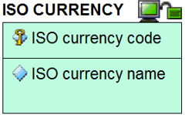The second type is an attribute. An attribute above the line (here shown with a key symbol overlaid on the diamond) represents a primary key – i.e. an ISO currency code uniquely identifies the ISO currency. Each ISO currency will also have an ISO Currency Name, but the code is the key.

The third type is a relationship, or ‘foreign key constraint’. The lines between entities with the different symbols represent the different variants there are to these relationships. The relationships include ‘one to one’, ‘one to many’ and ‘many to many’ but the exact relationship between the connected entities is described in words with a connecting phrase such as “qualifies the price of” or “is used by” or “contains allowed values for”. This connecting phrase will be contextual depending on the entities involved.

The variants of relationship differ from each other in other aspects:

|  |  |
| --- | --- |
|  | **Variant one:** The identifier of the first entity is passed as a non-identifying element of the other entity. |
|  | **Variant two:** The identifier of the first entity is passed as an identifying element of the other entity. The line between the two entities is a solid line. |
|  | **Variant three:** Many-to-many relationships. These typically require an intermediate entity to clarify the constraints |
|  | **Variant four:** Subtyping – where multiple entities have the same identifier but the subtypes need distinguishing from each other because they have different attributes. |

For further instructional material on how to read the CFIHOS Data Model, refer to the Data modelling Training Material [C-DM-901] on the CFIHOS SharePoint site.

For reference within the figures below, the following colour coding represents the source of the information:

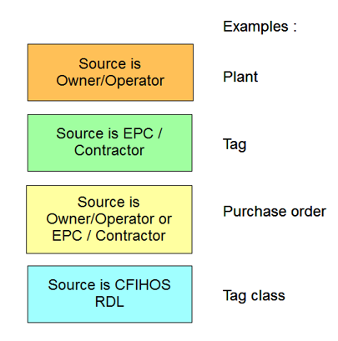

**A.2.2 High-level views of the CFIHOS data model**

Now you know more about the entity types and relationship types shown above, here are some examples from the CFIHOS data model. In order to understand the context of the entities that make up a capital facility, and all the elements that are required in the handover of information, the following four extracts from the overall data model cover the key areas.

It is important to appreciate that even extracts of specialist areas of the model – e.g. the part covering documents and document metadata – will always be a part of a bigger picture and the entities covered in one picture with the same name as those covered in another picture are by definition the same.

**High-level overview of the complete model**

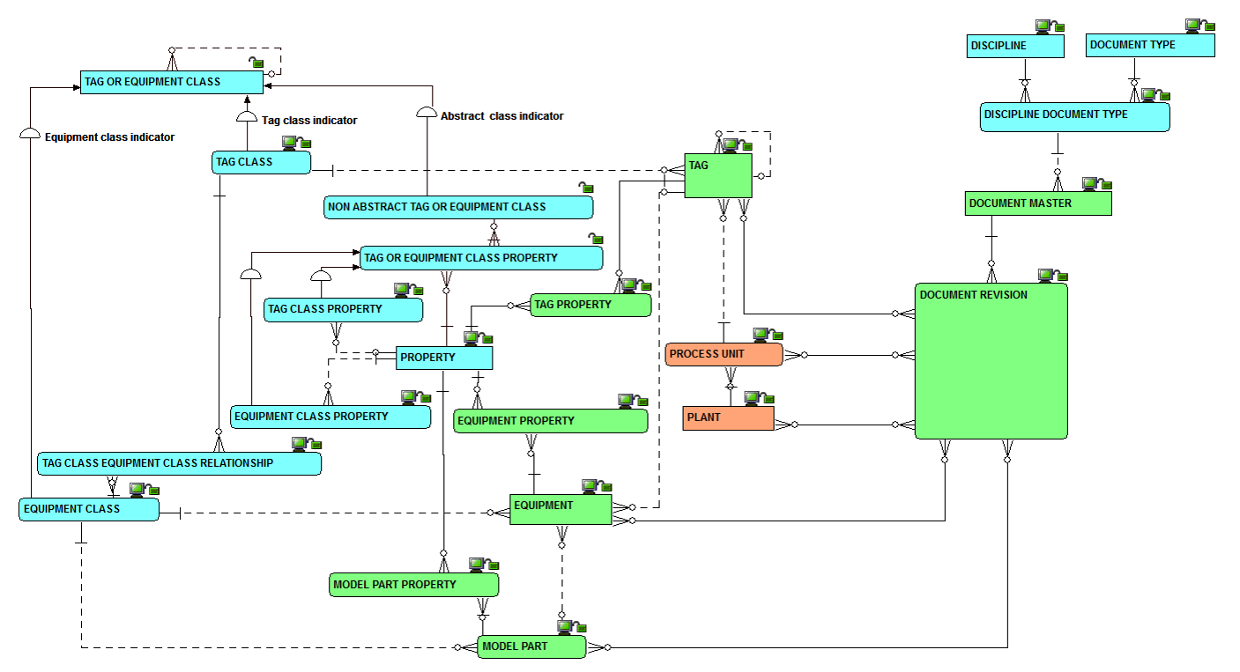

1. **Overview of the Plant Breakdown Structure**

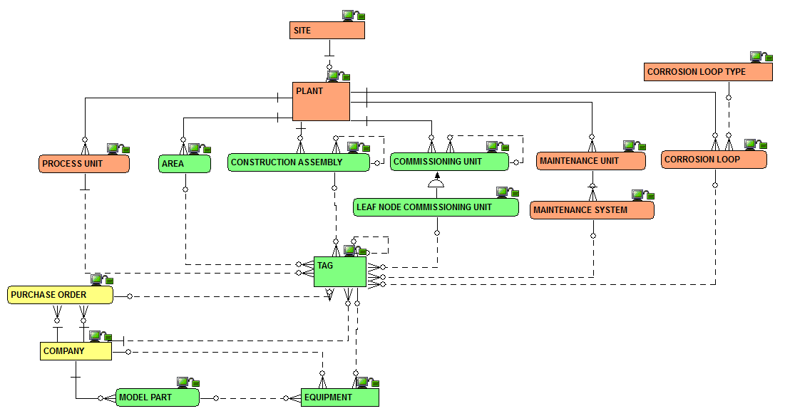

1. **Overview of the Classifications and Properties**

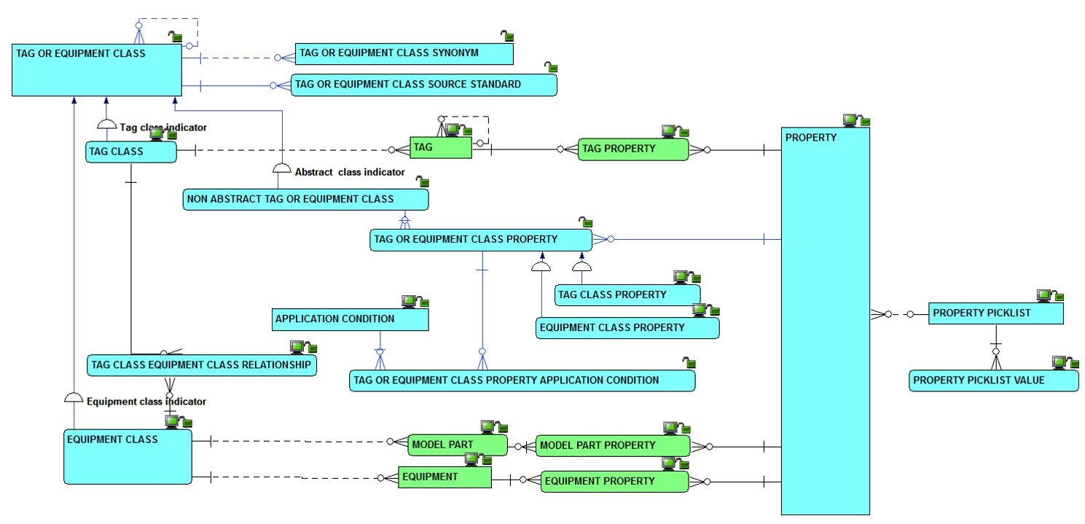

1. **Overview of the document management metadata**

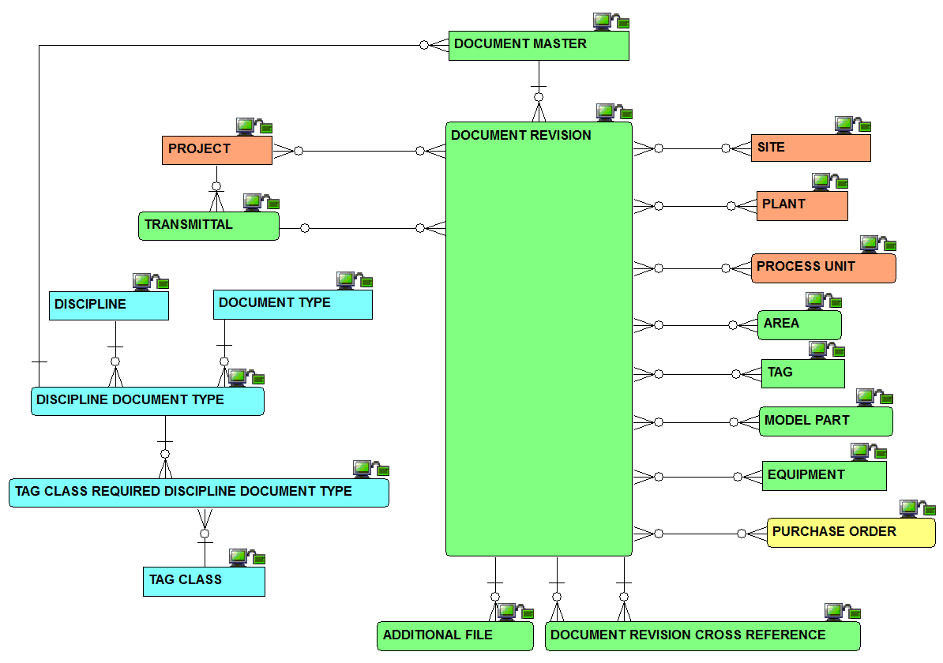

**A.2.3 Complete set of views of the CFIHOS data model**

The complete data model is available in the following formats:

* As a PowerPoint slide;
* In its native format.

Note – both of the versions come under the same document number [C-DM-001].

* 1. Data Dictionary

**A.3.1 How to understand the data dictionary**

For each CFIHOS Entity Object the data dictionary provides the list of attributes, with their definitions, examples, formats, optionality, constraints and sources.

The structure hereunder describes the content of each column in the data dictionary:

|  |  |  |
| --- | --- | --- |
| **Column** | **Field Name** | **Definition** |
| A | Section | Provides a unique reference to each entity, with some mapping to the section used in the previous edition. NOTE. This column is not shown in the light version of the data dictionary, as it is replaced by the name of the related Entity for filtering. |
| C | Name | The name of the entity (in the physical world: table) or attribute (in the physical world: column) |
| D | Definition | What the entity or attribute is/means/represents |
| E | Note/ comment | Supplementary information about the entity or attribute, though not part of the definition |
| F | Example | An example to assist in understanding. |
| G | Identifier/ Mandatory/ Optional | An indication whether the attribute is (part of) what identifies one occurrence of the entity, or, if not (part of- the identifier, whether the attribute is mandatory or optional |
| I | Format | An indication of attribute’s data type and its maximum size |
| J | Constraint | An indication of restrictions on allowable values of the attribute |
| K | CFIHOS unique id | A code that, in CFIHOS, identifies uniquely an entity or an attribute. (Note: this column is not shown in the light version of the data dictionary) |
| L | Data source | An indication of where the data is sourced from :   * The Principal * The Contractor/Supplier/manufacturer * A mix of both * The Reference Data Library (RDL) * The RDL, as a pick list ((note that the RDL pick list records are not shown in the light version of the data dictionary) |

**A.3.2 CFIHOS Data Dictionary excerpt**

Excerpt of the CFIHOS Data Dictionary provided below for reference:



**A.3.3 Access to the CFIHOS Data Dictionary**

The complete CFIHOS Data Dictionary can be found in document C-DM-002.

A lighter version of the data dictionary, which omits columns K and L (see above) is also available.

* 1. CFIHOS Reference Data Library

Refer to CFIHOS Reference Data Library (section 4.2)