CFIHOS – Implementation Guide for Contractor

Acknowledgements

In 2012, Shell approached Netherlands-based process industry organization USPI to explore turning their corporate information standard into an industry-wide standard. The result was the CFIHOS (Capital Facilities Information Handover Specification) project.

Its aim is to offer practical, standardized specifications for information handover that work across the supply chain – operators, contractors and suppliers. The most recent CFIHOS industry standard (Version 1.4) was published in October 2019 by USPI with support from the Engineering Advancement Association of Japan (ENAA). This document, describing the scope and procedures of CFIHOS, is part of this standard.

Following a member vote in 2019, the future governance, development, and maintenance of the CFIHOS project and standard moved from USPI to IOGP in January 2020, becoming Joint Industry Project (JIP)36.

Disclaimer
Whilst every effort has been made to ensure the accuracy of the information
contained in this publication, neither IOGP nor any of its Members past present or
future warrants its accuracy or will, regardless of its or their negligence, assume
liability for any foreseeable or unforeseeable use made thereof, which liability is
hereby excluded. Consequently, such use is at the recipient’s own risk on the basis
that any use by the recipient constitutes agreement to the terms of this disclaimer.
The recipient is obliged to inform any subsequent recipient of such terms.
This publication is made available for information purposes and solely for the private
use of the user. IOGP will not directly or indirectly endorse, approve or accredit the
content of any course, event or otherwise where this publication will be reproduced.

Copyright notice
The contents of these pages are © International Association of Oil & Gas Producers.
Permission is given to reproduce this report in whole or in part provided (i)
that the copyright of IOGP and (ii) the sources are acknowledged. All other rights are
reserved. Any other use requires the prior written permission of IOGP.
These Terms and Conditions shall be governed by and construed in accordance
with the laws of England and Wales. Disputes arising here from shall be exclusively
subject to the jurisdiction of the courts of England and Wales.

CFIHOS – Implementation Guide for Contractor

Version | Date | Comments/History
1.4 | April 2020 | IOGP republication of CFIHOS document first published in October 2019.

Foreword

The Capital Facilities Information Handover Specification (CFIHOS) is an industry standard developed to improve how information is exchanged between the companies who own, operate, and construct equipment for the process and energy sectors. Starting with a common equipment naming taxonomy and supporting specifications, its goal is to become a common language for the exchange of information in these sectors.

The initial focus is on information, both structured data and traditional document formats, which must be handed over when a project moves from its development to operations phase. Ultimately, the aim is for CFIHOS to become the de-facto standard for information exchange throughout the physical asset lifecycle, from vendor information through to decommissioning.

The Reference Data Library or “RDL” lies at CFIHOS’ heart. This library gives a standard and unified naming convention for equipment, its attributes, disciplines, and documents. Version 1.4 of the CFIHOS RDL includes:

- A list of classes for Tag and Equipment (what the equipment does and what it is)
- A list of properties (attributes, measures, characteristics etc.)
- Lists of requirements by class (data and document requirements)
- Standard unique coding of data to facilitate digital design and other workflows
- A list of document types
- A list of disciplines

At present, CFIHOS covers only the exchange of structured data and documents - not graphical, geometry, and model data. In the future, CFIHOS could be extended to include graphical and design tool and support spare parts procurement, inspection, test requirements, commissioning check sheets, Work Packaging, configuration management, and even drive payment.

CFIHOS is being developed collaboratively by project members as a practical standard to ensure the systematic and reliable exchange of information between all participants involved in the information supply chain, thereby reducing cycle times and costs. More than 70 organizations contributed to the development of CFIHOS Standard version 1.4, which is supported by several leading software industry design tools.

Contents

Foreword 3
1 Introduction 5
1.1 General 5
1.2 Scope 5
1.3 Target Audience 5
1.4 CFIHOS Document Structure 5
1.5 Terms, Definitions, Acronyms, and Abbreviations 7
1.6 Information Management Principles and Process in Projects 7
2 How to use the CFIHOS Standard on a Project 8
2.1 Contractual “Information Requirements Package” 9
2.1.1 Contract IM SoW 10
2.1.2 Contract Information Specification 10
2.1.3 Reference Data 12
2.2 CFIHOS Implementation Steps by the Contractor 12
2.2.1 Review and Confirm Understanding of the Information Requirements Package 13
2.2.2 Determine the Approach and Procedure for Changes to the Specification 13
2.2.3 Identify the Sources (Providers) of the Information. 13
2.2.4 Ensure Project-wide Awareness of the Requirements for Information and Quality 14
2.2.5 Implement Procedures & Tools for Information Collection, Validation, and Handover 14
2.2.6 Collect, Validate, and Consolidate Information 14
2.2.7 Perform Handover 14
3 Where to retrieve CFIHOS Documents, Tools, and Templates 15
Appendix A – Contract Information Requirements Package – Overview 16

Table of Figures
Figure 1: CFIHOS Document Structure 6
Figure 2: How to use CFIHOS on a Project, Overview 9
Figure 3: Contract Information Requirements Package 10
Figure 4: CFIHOS Implementation Steps 12

Introduction

General
This document describes how to implement the Capital Facilities Information Hand-Over Specification (CFIHOS) from a Contractor perspective. This guide does not discuss the expected organizational Information Management (IM) maturity required for effective implementation of the Specification.

Scope
This document covers the steps to be considered implementing the CFIHOS standard when received as part of a Contract Information Requirements Package up to and including the delivery of the information.

When using this document, it is recommended that the following should be referenced and understood together.
- CFIHOS Specification Document [C-SP-001];
- CFIHOS Implementation Guide for Principal [C-GD-001].
- CFIHOS Reference Data Library [C-ST-001];
- CFIHOS Data Model [C-DM-001];

For further instructional material on how to read the CFIHOS Data Model, refer to the Data modelling Training Material [C-DM-901] on the CFIHOS SharePoint site.

Target Audience
This document should be read by:
- Project Managers who are typically accountable for the delivery of project information to the asset;
- Engineering Managers who typically own the information to be specified and handed over;
- Project Information Managers and consultants who are typically responsible for specifying the information and implementing the handover process between the various stakeholders, based on the CFIHOS Specification and Reference Data Library;
- Engineers on the project responsible for generating, obtaining and reviewing the information;
- Personnel that configures IT systems needed to produce, validate or store the data and documents to be handed over.

CFIHOS Document Structure
The documents which form part of and support the CFIHOS standard are organized as shown in Figure 1. This guide, Implementation Guide for Contractor, is indicated in the red circle.
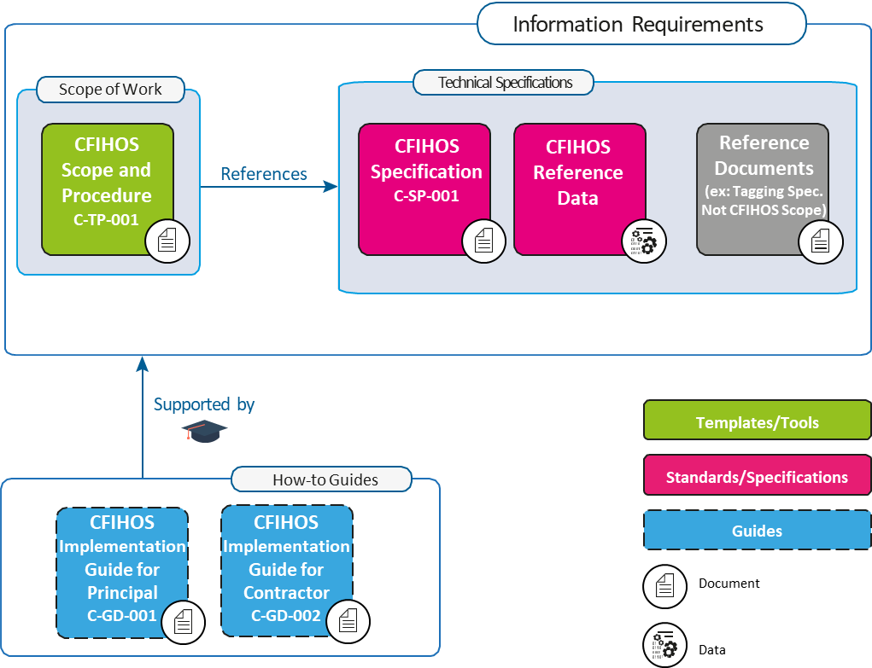
Figure 1: CFIHOS Document Structure

It is recognized that Principals may have different ways of organizing their contract documents for Capital Projects. For example, some Principals might include detailed descriptions of requirements within a Scope of Work, whereas other Scopes of Work might be a high-level description, with detailed requirements described in separate Specifications and Administration or Coordination Procedures.

Another difference is that some Principals collect all of their Information Requirements into a single Information Management Scope of Work, whereas others define Information Requirements alongside other requirements for different parts of the Scope of Work. However, the Principal chooses to organize its Information Requirements, the following must be included in order to benefit from the CFIHOS standard:

- “What” information is to be provided.

2. “How” the information is to be provided, including the format (document or data, file type) and how it is to be identified (document type, metadata, data identifier [CFIHOS Unique ID]).

3. “When” the information is to be provided. This is outside the scope of the CFIHOS Specification [C-SP-001]. However, the CFIHOS Scope and Procedure [C-TP-001] provides some basic information on this topic.

4. The quality measures used to understand the completeness, timeliness, and accuracy of the information. This is not currently addressed by the CFIHOS standard, however, the CFIHOS Scope and Procedure [C-TP-001] provides some basic information on this topic.

Terms, Definitions, Acronyms, and Abbreviations
A complete definition of terms is available in the CFIHOS Specification Document [C-SP-001]. A few key terms used in this document are included below.

Contract Information Management Scope of Work (IM SoW): In this contractual document the Principal specifies the terms and conditions for information delivery by the Contractor. Where it is applicable and feasible, quality benchmarks and criteria to fulfil may be included. For any details, there could either be reference to a specific specification document or included in the scope of work. CFIHOS Scope and Procedure document [C-TP-001] is used as a reference to create the project or contract specific Information Management Scope of Work. The term Project Information Management Scope of Work can also be used.

Contract Information Specification (CIS): The resulting document when this industry guideline is applied to a particular project describing the specific set of requirements to be fulfilled. Linked to this document is a Reference Data Library that describes the data characteristics and document types.
The CFIHOS Specification Document [C-SP-001] is the basis for creating a project or contract specific Information Specification.

Discipline Document Type: An association between Disciplines and Document Class names. In the CFIHOS context, the term Discipline Document Type is a unique identifier for types of documents, which allows deliverables to be specified and content ownership to be assigned by discipline. This term has been developed to cater for situations where a document class is common to more than one discipline, for example, a Data Sheet, which could be produced by different disciplines depending on the nature of the associated equipment.

Contractor (Or EPC Contractor): The party that carries out all or part of the design, engineering, procurement, construction, commissioning or management of a project or operation of a facility. The Principal may undertake all or part of the duties of the Contractor.

Principal (or Owner/Operator): The party that initiates the project and ultimately pays for it. The Principal may also include an agent or consultant authorised to act for, and on behalf of, the Principal.

Reference Data Library (RDL): The project/asset dictionary that provides a common language for the project or asset by defining, in detail, the classes (e.g. tag and equipment) and their attributes (i.e. properties) required to be used for the electronic handover of information. Reference Data for use in commercial contracts (and for the configuration of software solutions) is generated from the Reference Data Library, which serves as the master of all reference data associated with the project or asset. The CFIHOS RDL also includes the CFIHOS Unique ID codes.

SEED file: File that contains set-up information that must be loaded for a software application to work properly. A seed file may contain class, type and attribute definitions, UOM, symbols, catalogues, assemblies, valid value lists, breakdown structures, report definitions, etc. The content of a seed file varies based on the standardization and application integration requirements of its provider.

Shall is used to dictate absolute requirements.

Should is used to describe recommendations where noncompliance can be acceptable.

Information Management Principles and Process in Projects
For this implementation guide, a few key points are important:

- A Capital Project typically delivers two assets to the Principal organization; a physical asset and an information asset;

- Principals are responsible for specifying the requirements for both the physical asset and the information asset;

- EPCs, Equipment Suppliers and other third parties are responsible for creating and delivering a high-quality information asset to the Principal, which in turn can be used for Operations, Maintenance and possible future Modifications;

- The information asset will include both Documents (printed or electronic, for human interpretation) as well as Data (stored in a structured format and manipulated using software applications).

From a Contractor perspective, the information management process involves the following main steps:

- Review and confirm understanding of the CFIHOS based information and compliance requirements for deployment in the project execution environment.

- Identify the sources (providers) of the information.

- Align the project execution environment in terms of organization, procedures and systems for information generation, collection, validation, and handover.

- Capture, consolidate and validate the information to ensure the quality of the information deliverables is compliant with the requirements.

- Handover information deliverables to the Principal

- Correction of deliverable non-conformances and handling of changes in the requirements due to project developments

How to use the CFIHOS Standard on a Project
This chapter describes how the CFIHOS standard could be applied to a project.

The information exchange process starts with the review of the information requirements package, deciding how to meet the requirement and implementation by configuring and/or mapping internal information systems to comply with CFIHOS, and by specifying CFIHOS compliant deliverables in any sub-contracted work.

In Figures 2 and 4 and the following sections, the implementation process for the Contractor is described in more detail.

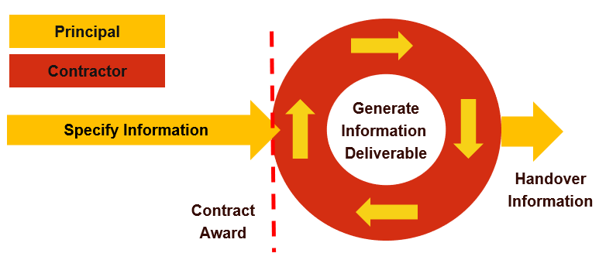
Figure 2: How to use CFIHOS on a Project, Overview

Contractual “Information Requirements Package”
The Principal typically has a contracting and procurement process by which a ‘Prime Contract’ or another contractual vehicle is agreed with a Contractor to deliver a project scope. The Principal’s information requirements are included in this ‘Prime Contract’ or another contractual vehicle, as appropriate. Often, these information requirements are outlined in an “Information Requirements Package” consisting of the following documents created by the Principal (based on the CFIHOS Standard). See Figure 3 and section 1.5 for terms and definitions:

- Contract Information Management Scope of Work (IM SoW)

- Contract Information Specification (CIS), including
  - Reference Data (CFIHOS RDL)
  - Reference Documents (Not in CFIHOS scope) most likely to be Principal specific.

Figure 3: Contract Information Requirements Package

Depending on the structure of each Principal’s Prime Contract, the contractual requirements covering information management and handover may not necessarily be centralized into a single Information Requirements Package and may be found dispersed throughout the Prime Contract.

However, in this guide, the terms “Information Requirements” and “Information Requirements Package” have been used interchangeably as described above. The specification of the internal processes of the Contractor or the Principal is not part of the scope of this document.

Contract IM SoW
The goal of the Contract IM SoW document is to define certain aspects of the information requirements, i.e. the scope, processes, interdependencies and acceptance criteria for the exchange and handover of information between Contractor and Principal. It allows the Contractor to understand the expected deliverables, their timing and other success criteria, and it should enable the Principal to monitor the quality and progress of information creation and delivery in a progressive manner before the final handover.

The IM SoW points to the Contract Information Specification which should identify what information is required to be delivered.

Contract Information Specification
The goal of the Contract Information Specification is to define the technical aspects of the project information requirements; for which CFIHOS forms the basis. CFIHOS identifies a full generic super-set of information that may be produced in a project. In practice, the information specification will include a template that reflects the contract scenario applicable to the project.

The template specifies what information a Principal delivers to a Contractor (e.g. naming conventions, classifications etc to be used) and what information the Principal expects to be delivered back by the Contractor (e.g. design data and equipment documentation). These scenarios/templates are:

Template 1: EPC or ESC
Information requirements to be delivered for an Engineering, Procurement & Construction (EPC) Contract or Engineering Services Contract (ESC) contract scope.

Template 2: FEED
Information requirements for a Front-End Engineering Design (FEED) Contract. In this Template, the procurement or delivery of any hardware, and associated information is considered to be out of scope.

Template 3: Document Only
Information requirements for a Contract delivering documents only. This may include scenarios like Conceptual Engineering, Surveys/Studies and Site Preparation.

Template 4: Package Vendor
Information requirement for engineered equipment packages (i.e. skids, part of a plant), including how to code, format and exchange information (for review and handover) between Contractor and Principal. Typically, the scope is similar to an EPC Contract, but the volumes are smaller.

Template 5: Standard Equipment
Information requirements for standard (off-the-shelf) equipment purchase orders, including how to code, format and exchange information (for review and handover) between Contractor and Principal.

Additional project specific requirements
The CFIHOS template requirements may be augmented with the following additional requirements:

- Information requirements not covered by CFIHOS: These may include corporate practices or scope not currently included in CFIHOS.

- Project Specific reference data/specifications: These include taxonomies, object coding and naming conventions that are specific to the project or asset which the Principal expects Contractor to use for labelling or classification purposes.

- Brownfield projects may decide to comply with the numbering and classification structure of the original asset.

Local needs
Local needs for Documents or Data may be driven by local regulations which are not part of CFIHOS such as:

  - The need for a specific number of paper copies and their sizes;
  - The delivery of quality certificates in accordance with local (government) regulations;
  - (Bi)-lingual information deliverables.

Validation procedures
The Principal will have developed validation procedures that will be used to assess the progress and to review the quality of the information delivered by the Contractor.

Reference Data
The reference data library (RDL) is a collection of information in a formal manner such that it is suited for (automatic) processing, interpretation, and communication.

The project RDL, based on the CFIHOS standard RDL [C-ST-001] is tailored to specify the reference data for the contract scope.

The Principal may have populated and made available to Contractor in a project engineering information repository/Engineering Data Warehouse with reference data that will be utilized to specify the project RDL and/or for publishing the quality checked information during the project. It can also ensure that any software templates to be furnished by the Principal for use by the Contractor is compliant with the RDL.

The reference data is an attachment to the Contract Information Specification.

CFIHOS Implementation Steps by the Contractor
Upon receipt of the Information Requirements Package, the Contractor would typically engage a Project Information Management organization with adequate skills to coordinate and execute the following steps.
Figure 4: CFIHOS Implementation Steps

Review and Confirm Understanding of the Information Requirements Package
The CFIHOS based Information Requirements Package, including additional project specific requirements, shall be reviewed for unambiguous and consistent definition.

This review should include the feasibility of the completeness and quality expectations for multiple or continuous deliveries during project execution as the quantity and the quality of the information will only gradually become available.

In case the Principal provides templates (SEED files) for software applications and/or deliverables to be used by Contractor, the compatibility of these templates with the information requirements shall be reviewed.

This review is conducted by subject matter experts from Project Information Management, Technical Disciplines and often requires close cooperation with the Principal to clarify unclear items or confirmation of Contractor’s interpretation.

A review typically consists of checking that:

- The information items requested are unambiguously defined and are well understood.
- Any deviations from the CFIHOS standard have been identified.
- The validation criteria are clearly defined to allow automated quality checks and reporting.
- It is feasible to provide information and quality at the requested delivery milestones.
- There are procedures defined to handle information changes between deliveries (adds, replacements, deletes, modifications).
- In case the handover of Contractor engineering tools part of the requirements there is a consistency requirement between these tools (configuration/seed files) and the CFIHOS handover specification.
- Consistency of Principal provided templates for deliverables and/or engineering tools (if any) with the other parts of the Contract Information Requirements Package. This applies to classifications, properties, picklists, Units of Measurement, etc.
- Availability of a mapping between CFIHOS and specifications specific to the information delivery into plant operation & maintenance systems.
- The extent to which Principal defined project numbering systems for assets and documents are consistent with the CFIHOS based Contract Information Specification.
- The method, format, meta-data, and frequency of information hand-over are clearly defined.

Note: A significant contributor to the efficient management of information is a complete and consistent project numbering system for objects like tags/equipment and documents. It shall also be clear which objects (classes) are subject to tagging/numbering.

In general, plant operation & maintenance requirements lead to tagging/numbering of more object classes compared to those relevant for Contractor’s traditional scope and work processes. The project numbering specification shall be complete and cover these object classes.

Determine the Approach and Procedure for Changes to the Specification
Information structures, naming conventions and reference data/documents should remain fixed for the whole life cycle. In practice however, changes to the specification will occur during project execution. These changes may be initiated by the Principal or may be needed by the Contractor or its suppliers. Typical examples are properties and property pick list values. A change management approach and implementation strategy shall be agreed with the Principal.

Identify the Sources (Providers) of the Information.
These are parties, internal and external to Contractor. Typically, these are the EPC disciplines of the Contractor, (equipment) suppliers, sub-contractors and in some cases, content providers specialized in supplying information for the process industry.

It is good practice to manage this responsibility in a matrix that indicates which discipline and organization (internal and external) need to deliver what information and when.

Ensure Project-wide Awareness of the Requirements for Information and Quality
It is important that the necessary milestones, controls and incentives are cascaded into the total supply-chain along with the CFIHOS based information specification. This is achieved by the creation of specifications, instructions and organizing clarification and induction sessions dedicated to the parties involved.

In this process, focal points could be assigned from these parties. These focal points will be accountable for the provision of the information. It is important that among other project priorities (e.g. order placement for equipment to meet the schedule) the information delivery requirements remain a high priority. Clear and repeated support from project management in this area is crucial.

Implement Procedures & Tools for Information Collection, Validation, and Handover
Identify the capabilities of the (external) parties, procedures, and systems for providing and collecting and validating the information. For a first implementation of CFIHOS an important part of the work in this step is the mapping of the requirements to information (templates) contained in the systems used by Contractor and/or external parties and implementing modifications to meet as much as practical the CFIHOS specification.
CFIHOS is targeted at the information required by a Principal to operate and maintain a plant or for any future design changes. Because of this, it does not necessarily cover all information required by Contractor to execute its EPC work processes.

Certain information from an equipment manufacturer/supplier (e.g. shipping weight) may not be covered by CFIHOS while required by the Contractor. The Contractor shall review and determine the best method to gather both the CFIHOS and any additional data required from its information suppliers.

The scope of CFIHOS is (and will become) more extensive compared to today’s document and data hand-over requirements. It includes many relations between objects like documents to tag, document to equipment, tag to tag, etc. On larger size projects it is recommended to make use of a data warehouse application for collection and consolidation of this information. The data warehouse can further serve as the source for (continuous) validation and the transformation and hand-over to the Principal.

Cost savings can be realised by reusing the outcome of these efforts on subsequent projects with similar “CFIHOS based” requirements.

Collect, Validate, and Consolidate Information
Expedite the delivery milestones and perform collection, validation, and consolidation of information. Ensure timely resolution of findings that prevented passing validation.

The definition and implementation of a validation system is crucial for an efficient and successful handover. The system should be based on the validation criteria in the Contract Information requirements Package and the engineering & design tools used on the project. Where possible, upfront validation (e.g. in design tools) is preferred as it avoids the more extensive correction effort that would be required from issues detected later in the process.

If possible, the Contractor shall execute the same validation (system) as employed by the Principal before a handover transmission. This will limit the number of time-consuming feedback loops for the resolution of issues.

Perform Handover
Issue the information to the Principal in the required formats and/or systems accompanied by meta-data related to the transmission.

Different methods for information handover to the Principal may apply, ranging from batch deliveries near the end of the project or every couple of months to almost continuous (daily) incremental delivery into cloud-based systems.

Whichever method is used, the implementation of a handover management system is required that allows the sender (Contractor) and receiver (Principal) to determine what is sent and what is changed together with other meta-data about transmission (revision, status, date/time, issue purpose, etc.).

On receipt of the information, the Principal will perform a review and validation of the information. It is important that the validation results transmitted back to the Contractor have agreed and meaningful classifications and descriptions to allow efficient resolution and progress monitoring.

Where to retrieve CFIHOS Documents, Tools, and Templates
The CFIHOS team is using the SharePoint platform for publishing the standard. CFIHOS Version 1.4 Reference Data Library is published as a set of .CSV files. Access can be granted by the CFIHOS project leader and is at the moment restricted to the members of the CFIHOS team.
(https://uspinl.sharepoint.com/CFIHOS/download/Shared%20Documents/Standard%20publications/Current%20Version%201.4)

There are the following entries:
- CFIHOS Reference Data Library (RDL) [C-ST-001]
- CFIHOS Data Model [C-DM-001] and CFIHOS Data Dictionary [C-DM-002]
  - CFIHOS Data Model Training Material [C-DM-901]
- CFIHOS Narrative Set
  - CFIHOS Implementation Guide for Principal [C-GD-001]
  - CFIHOS Implementation Guide for Contractor [C-GD-002]
  - CFIHOS Specification Document [C-SP-001]
  - CFIHOS Scope and Procedure Document [C-TP-001]

RDL Contents of RDL zip file:
- CFIHOS discipline V1.4.csv
- CFIHOS document type V1.4.csv
- CFIHOS discipline document type V1.4.csv
- CFIHOS property V1.4.csv
- CFIHOS property picklist value V1.4.csv
- CFIHOS property picklist V1.4.csv
- CFIHOS tag class V1.4.csv
- CFIHOS tag class properties V1.4.csv
- CFIHOS tag class required discipline document type V1.4.csv
- CFIHOS tag equipment class relationship V1.4.csv
- CFIHOS equipment class V1.4.csv
- CFIHOS equip class properties V1.4.csv
- CFIHOS model part class properties V1.4.csv
- CFIHOS unit of measure dimension V1.4.csv
- CFIHOS unit of measure V1.4.csv
- CFIHOS RDL Master Objects V1.4.csv

Appendix A – Contract Information Requirements Package – Overview
Figure A-1: Contract Information Requirements Package based on CFIHOS

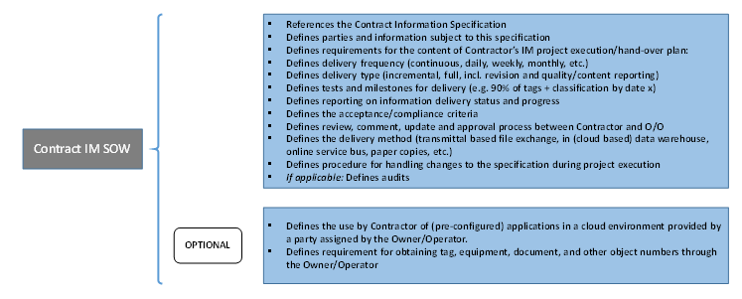
Figure A-2: Contract IM Scope of Work content based on CFIHOS

Figure A-3: Contract Information Specification content

